**IGNOU – Indira Gandhi National Open University**

**SHAHBAZ ANSARI – MCA (MCS044)**

**ENROLLMENT NO - 145359210**

**Project Title**

**Online Maintenance Management System**

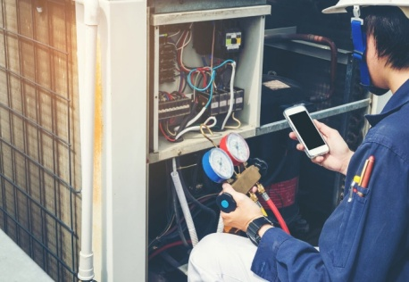

**Submitted By – Shahbaz Ansari (BCA)**



**UnderGuidance of - SANTOSH KUMAR SAH**

**“ONLINE MAINTENANCE MANAGEMENT SYSTEM”**

**Submitted to:**

**INDIRA GANDHI NATIONAL OPEN UNIVERSITY**

In Partial fulfillment for the award of the degree of

***MCA (Master Degree of Computer Application)***

**Session July 2018 – January 2019**

**MCS-044**

**Under the Guidance of: Santosh Kumar Sah**

**Submitted By:**

**Name : SHAHBAZ ANSARI**

**Enrollment No. : 145359210**

**Programme : MCA**

**Project Code : MCS044**

**Study Centre : 0758P**

**Address : H.No. 196, New Priyanka Camp, Madanpur Khadar Sarita Vihar, New Delhi – 110076**

**Mobile No. : 8802537803**

**Table of Content**

|  |  |  |
| --- | --- | --- |
| **Resume of the Project Guide** | | |
| **Certificate of Originality** | | |
| **Serial No.** | **Tittle** | **Page No.** |
| **1.** | **Title of Project** | **2** |
| **2.** | **Project Performa** | **3** |
| **3.** | **Index** | **4** |
| **4.** | **Acknowledgement** | **5** |
| **5.** | **Introduction** | **6-7** |
| **4.** | **Objectives** | **8-9** |
| **5.** | **Feasibility Study** | **10-11** |
| **6.** | **Project Planning and Scheduling** | **11-13** |
| **7.** | **Tools/Environment Used** | **14** |
| **8.** | **Analysis Document** | **15-17** |
| **9.** | **ER Diagram** | **18** |
| **10.** | **DFD Diagram** | **19-23** |
| **11.** | **User Case Diagram** | **24-25** |
| **12.** | **Design Documents** | **26-32** |
| **13.** | **Program Codes** | **33-94** |
| **14.** | **Testing** | **94-97** |
| **15.** | **Input Output Screens** | **98-122** |
| **16.** | **Implementation of Security** | **123** |
| **17.** | **Limitations of Project** | **124** |
| **18.** | **Future Application of Project** | **125** |
| **19.** | **Bibliography** | **125** |

**Acknowledgement**

**I wish to express my deep gratitude to my honorable Project Manager Mr. SANTOSH KUMAR SAH for his valuable and expert guidance, which had been constant source of my inspiration and motivation. Finally I am very grateful to entire staff & colleagues that help me in such a great analysis of the project.**

**It is my pleasant duty to thank all the staff member of the computer center who never hesitated me from time during the project. Finally, I gratefully acknowledge the support, encouragement & patience of my family, and as always, nothing in my life would be possible without GOD.**

**Thank You!**

**Shahbaz Ansari**

**MCA**

**Introduction**

This MM (Maintenance Management) project is focusing the preparation of such a Portal or Website, which intends to provide Maintenance Services to its customers on different household electrical and electronics products such as TV, Washing Machine, Refrigerator, Air Conditioners, Air Coolers, and Microwave Ovens etc.

The reason behind the creation of a website named Online Maintenance Management System where clients can access or get information about electrical and electronics products such as TV, Washing Machine, Refrigerator, Air Conditioners, Air Coolers, and Microwave Ovens etc in their locality or Brands by just visiting this site with a single click of a mouse. So they get the desired information electrical and electronics products such as TV, Washing Machine, Refrigerator, Air Conditioners, Air Coolers, Microwave Ovens etc in emergency for routine appointments replacements parts with Website or make a schedule with Admin by sending them mail or by call them on their contact number through the contact number which will appear in a display in their page.

# The main features of this software would be follows as:

1. Collection of Information about the electrical and electronics products.
2. Collection of information about the Customers or Clients.
3. Creation of Clients Appointment with collecting the suitable information from the clients/customers.
4. Creation of Clients Account with collecting the suitable information from the Appointment Form and registers them with Appointment ID so Clients can Change their information by their Appointments ID which are posted on website.
5. Creation Online Maintenance Management System Account with collecting the suitable information from the Websites authorities and Register them so they can edit the data with their Admin ID which they posted on website, so the details will be displayed to the user when they access the information of Online Maintenance Management System.
6. Creation of Admin account so they can login on the website using their Admin ID and Password.
7. It will display the Name of Products Parts (Items) when user selecting a Products from the Dropdown List or just clicking a link of the particular Products parts.
8. There is facility to receive/send mail to Clients or any one visit website or get the message suggestion or bulletin regarding the Products.

The present epoch is given the information Technology. IT is a new and fresh integrated approach and a key to unlock all the intricate problems of our modern era.

This technology tends to cater all our needs. It is not only an ‘Integrated Approach’, but also job-oriented & concrete device to aware us of the up-to-date skill and knowledge.

IT is instructive as well. It is an instrument of bringing us to a realm of technology. It has entirely revolutionized the vista of the modern world. It has made the modern life easier, softer, better, happier and more prosperous.

It has worked a magic wand in the spheres of industry, marketing, Maintenance, replacement, transportation, electronics & electrical devices. IT has boosted progress beyond description. It has given us the safest & the most concrete means of instruction i.e. Computer, Internet, E-mail, Maintenance Management, replacement, Website and a lifeline for most of our problems.

IT affords us of whatever we could not dream of. All these devices under IT have drastically changed communication that now links the world within the twinkling of an eye.

IT has to a larger extent, played a role in bettering the global economy. Although there are many companies offering these services but still quality work is always in denied.

* 1. **Purpose**

The purpose of this document is to describe the external requirements for Online Maintenance Management System website.

* 1. **Scope**

This document is the only one that describes the requirements of the system. It is meant is the only one that describes the requirements of the system. It is meant for use by the developers and will be the basis for validating the final delivery system. Any changes made to the requirements in the future will have to go through a formal change approval process.

# ****OBJECTIVE****

The objective of this project is to provide facility of online information of Online Maintenance Management System to the Users.

In an era where information is most important to the persons, institutes and organizations, as most of the money spent by these groups to gather the information and process the data for its effective storage of information in a way that information remains effective, efficient and non redundant, there was little importance given to the way the information was stored and retrieved as per their needs. Not only the information is ineffective and inefficient, it also gets redundant, thus making job of the System Administrator more and more difficult.

In earlier age there is no any medium to know the information about Online Maintenance Management System so they can approach them. To overcome this problem we are going to develop a website from that the user can get the information of electrical and electronics products , Brands or Websites in their locality or anywhere in India so they can contact the Admin or Websites or Blogs and take information. This web portal is used to make his work very easy. Moreover this approach increases efficiency in Data and effectiveness in information stored.

The objective of this project is to provide facility of online information of Admin, Products or Websites to the Users. To design a software package, which helps the user or Buyer to retrieve the data of the Admin or Websites who has posted their details on the job portal? Hence the software is known as “Online Maintenance Management System”.

Online Maintenance Management System part would enable users or buyer gather information of particular Admin, electrical and electronics products or Websites. At the end of this part of project we will able to achieve following goals.

* This will provide the facility of APPOINTMENTS by which Clients will able to take Appointments by Client’s
* Admin will register them and post their data on the website that would be available to the clients or customers. Later they can edit the data which they posted on the website by using their Appointment’s ID and Password.
* Admin will able to achieve use special function like make the status of Replacements active or not active. By review their Charges and duration of validity. They grant privileges to the clients according to their ID. Alter the rates of posting made by Admin or Websites and collection of charges and handle queries.
* Administrator allow the Clients, Admin to change their Password or any information which they submit earlier.
* All type of information like user’s details or Products/Websites details will be available for Clients. Clients will able view and replacements the Product’s Parts on Website according to their selected Product’s Parts.
* Clients will able to take appointment them to use some prohibited features like mail facility through which they can mail to anyone or Users to visit websites.

The software package will enable the Administrator to do administration on the data which are posted by different clients, admin, product’s parts and Websites more efficiently, effectively with no more redundancy in data. The software is build using PHP as Front End and PHP MyAdmin SQL Server as Database.

**PROJECT CATEGORY**

This software information is handled by using PHP MyAdmin for storing records in a database, as backend, PHP is used as front end. JAVASCRIPT is used as a scripting language, CSS (Cascading Style Sheets) is a style sheet language used for describing the look and formatting of a document written in a markup language and PHP is used to make the page attractive. Caching is used to make less traffic on the Server.

Project categorized in a web based system, which keeps all the information about Products and Services spreading all over the India. So any one can get the details of Products And Services by single click of Mouse in their locality or anywhere in India.

**FEASIBILITY STUDY**

The feasibility study is carried out to test whether the proposed system is worth being implemented.Feasibility study is a test of system proposed regarding its work ability,its impact on the organization ability to meet user needs and effective use of resources.It is usually carried out by a small number of people who are familiar with the information system techniques, understand the part of the business or organization that will be involved or effected by the project and ares killed in the system analysis and design process. A feasibility study involves taking a judgement call on whether a project is doable. The two criteria to judge feasibility are cost required and value to be delivered. A well-designed study should offer a historical background of the business or project, a description of the project or service, accounting statements, details of operations and management, marketing research and policies, financial data, legal requirements and tax obligations. Generally, such studies precede technical development and project implementation. The feasibility study is carried out to test whether the proposed system is worth being implemented.

The key consideration involve in the feasibility study are:

1. **Technical Feasibility-** assessment is centered on the technical resourcesavailable to the organization. It helps organizations assess if the technical resources meet capacity and whether the technical team is capable of converting the ideas into working systems. Technical feasibility also involves evaluation of the hardware and the software requirements of the proposed system.
2. **Economic Feasibility**- helps organizations assess the viability, cost, and benefits associated with projects before financial resources are allocated. It also serves as an independent project assessment, and enhances project credibility, as result. It helps decision-makers determine the positive economic benefits to the organizations that the proposed system will provide, and helps quantify them. This assessment typically involves a cost/benefits analysis of the project.
3. **Operational Feasibility-** this involves undertaking a study to analyze and determine whether our business needs can be fulfilled by using the proposed solution. It also measures how well the proposed system solves problems and takes advantage of the opportunities identified during scope definition. Operational feasibility studies also analyze how the project plan satisfies the requirements identified in the requirements analysis phase of system development. To ensure success, desired operational outcomes must inform and guide design and development. These include such designed-dependent parameters such as reliability, maintainability, supportability, usability, disposability, sustainability, affordability, and others.

**Project Planning and Scheduling**

***Gantt chart***

This chart represents all the activities and the amount of time that will require during the product development period. A tabular form is maintained where rows indicate the task with milestones and columns indicate duration

|  |  |  |  |  |  |
| --- | --- | --- | --- | --- | --- |
| Phase/Month | 10th Feb2019 | 17th Feb 2019 | 21st Feb 2019 | 07th Mar 2019 | 30th Mar 2019 |
| Requirement  Gathering |  |  |  |  |  |
| Analysis |  |  |  |  |  |
| Designing |  |  |  |  |  |
| Review |  |  |  |  |  |
| Coding |  |  |  |  |  |
| Testing |  |  |  |  |  |
| Implementation |  |  |  |  |  |

##### **ACTIVITY TIME ESTIMATE CHART**

|  |  |  |  |  |
| --- | --- | --- | --- | --- |
| **ACTIVITY CODE** | **OPENING** | **CLOSING DATE** | **TOTAL TIME** | **PROJECT NAME** |
| 1 | 10/02/2019 | 30/03/2019 | 1 Months & 2 Week | **Online Maintenance Management System** |

**PERT CHART-**

Scheduling of a software project does not differ greatly from scheduling of any multitasking engineering effort. Therefore generalized project scheduling tools and techniques can be applied with little modification to software project. PERT (program evaluation and review technique) is project-scheduling methods that can be applied to software development. PERT techniques are driven by information already developed in eastern project planning activities.

PERT provide quantitative tools that allows the software planner to determine the critical path -The chain of task determines the duration of the project; establish, ”most likely “ time estimates for individual task applying statistical models; and calculate: ”boundary time “ that define a time “window for a particular task.

Boundary time calculations can be very useful in software project scheduling. PERT have been implemented in a wide variety of automated tools that are available for the personal computer. Such tools are easy to use and make the scheduling methods described previously available to very software project manager.

Now the Pert chart of the above data is as follows:

## PERT CHART

Build Menu Frame

10th Feb 2019 17th Feb 2019 21st Feb 2019 07th Mar 2019

Write Manual

Finish

Build Dialog Boxes

Build All php database

Integration & Test

Design

Start

17th Mar 2019

30th Mar 2019

27th Mar 2019

**TOOLS/PLATFORM, LANGUAGES TO BE USED**

Software and hardware specification as the name suggests, tells us about the various characteristics of the software and the hardware environment used i.e. the development environment used. Here we specify various software languages, supporting tools that have been used for the development of the system. These tools and the languages have been used because of their relative ease of understand and personal interest of the team developing the project.

**HARDWARE REQUIREMENTS SPECIFICATIONS**

**HARDWARE**

**Processor : Pentium 2.4GHz or Above**

**Memory : 256 MB RAM or Above**

**Cache Memory : 128 KB or Above**

**Hard Disk : 250 GB or Above**

**Keyboard : Any Keyboard**

**Mouse : Any Mouse**

**SOFTWARE :-**

**Operating System : Windows 7,8.1,10**

**Front End Tool : HTML5, CSS3, JavaScript, Bootstrap,**

**PHP**

**Back End Tool : PHP MyAdmin**

**Technology** :  **Sublime, Bracket**

**Browser** : **Chrome, Mozilla**

**Server** :  **XAMPP, Apache**

**SOFTWARE REQUIREMENTS SPECIFICATION**

In this Project the Software Requirements Specification is produced at the culmination of the analysis task. The function and performance allocated to software as part of system engineering are refined by establishing a complete information description, a detailed functional description, a representation of system behavior, an indication of performance requirements and design constraints, appropriate validation criteria, and other information pertinent to requirement.

The introduction to software requirements specification states the goals and objectives of the software, describing it in the context of the computer based system.

The information description provides a detailed description of the problem that the software must solve. Information content, flow, and structure are documented. A description of each function required to solve the problems is preserved in the functional description.

Validation criteria are probably the most important and, ironically, the most often neglected section of the software requirements specification.

Software specification can be used for different purposes. Here are these major uses.

Statement of user needs:

A main purpose of the product specification is to define the need of the product’s user. Some times, the specification may be a part of a contract sign between the producer and the user. It could also form part of the user manuals. A user’s needs are sometimes not clearly understood by the developer. If this is the case, a careful analysis involving much interaction with the user should be devoted to reaching a clear statement of requirements, in order to avoid possible misunderstandings.

Sometimes, at the beginning of a project, even the user has no clear idea of what exactly the desired product is. Think, for instance of user interfaces. A user with no previous experience with computer products may not appreciate the difference between, say, menu driven interaction and a command line interface. Even an exact formulation of system functions and performance may be missing an initial description produced by an inexperienced user.

**A statement of the requirements for the implementation:**

Specifications are also as a reference point during product implementation. In fact, the ultimate goal of the implementation is to build a product that needs specification. Thus the implementers use specifications during design to make design decisions and during the verification activity to check that the implementation compiles with the specification.

**SOFTWARE ENGINEERING PARADIGM APPLIED**

To solve actual problems in an industry setting, a software engineer or a team of engineers must incorporate a development strategy that encompasses the process, methods, and tools layers. The strategy is often referred to as a process model or a software engineering paradigm. A process model for software engineering is chosen based on the nature of the project and application, the methods and tools to be used, and the controls and deliverables that are required.

**There are numbers of paradigm available:**

* The Linear Sequential Model
* The Prototype Model
* The RAD Model
* The Incremental Model
* The Spiral Model
* The Component based development Model
* The Concurrent Development Model
* The Formal Methods Model
* The Fourth Generation Technique Model

The Model, which has been applied in my project, is the Rapid Application Development (RAD). For the same reason .NET is used as the programming tool because it provides us with the components that have already been made and we can use them as it is. This reduces the time and cost incurred on completing the project. While automating the work procedure of a “DoctosIndia.Com” no new classes were needed, hence RAD was the most suitable technique.

**SYSTEM DEVELOPMENT LIFE CYCLE**

SDLC is an acronym for Software Development Life Cycle.It is also sometimes referred to as System Development Life Cycle.In simple words it the process, methods or aset of methodologies applied to create or alter software projects. Each of these methodologies defines unique way to create anew software module or program. The SDLC aims to produce a high-quality software that meets or exceeds customer expectations, reaches completion within times and cost estimates. The life cycle defines a methodology for improving the quality of software and the overall development process.

SDLC is the acronym of Software Development Life Cycle.

It is also called as Software Development Process.

SDLC is a framework defining tasks performed at each step in the software development process.

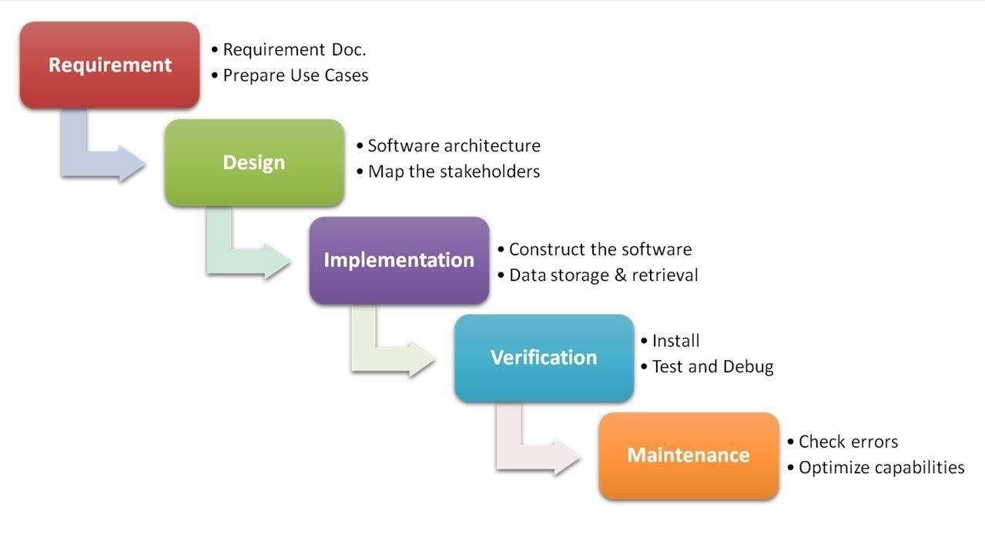

Following are some model which is used for Software or System Development Life Cycle

1. Waterfall Model
2. Build and Fix Model
3. Spiral Model
4. Prototype Model
5. Interactive Enhancement Model
6. RAD Approach

From above SDLC modeI choose waterfall model to develop this project.Waterfall model has the simplest life cycle whereas Win-Winspiral model has the most complex one.So,on the basis of feasibility studies,requirement factor and size of the project.I have choose **WaterFall Model** to develop this project.

Entity relationship diagram

view

password

Email

1

1

Admin

1

id

product

Dop

price

view

Preventive maintenance repair services

**CONTEXT LEVEL 0-LEVEL DFD**

phone

Product type

Complain about

Buy fault repair service

M

password

speciality

Add engineer

M

M

M

M

M

M

M

M

M

request

defect

dom

id

brand

email

id

gender

name

Name

password

Email

user

send

Service_type

Id

email

Complain

engineer

**Login**

**Receive 2 months warrenty on replaced part**

**Fault Repair Request**

**Use services after login**

**Feedback /support**

**Buy Preventive Maintenance Service**

**Receive support query**

**Preventive Details**

**Manage Fault Repair**

**USER**

**ADMIN**

**Offline Payment**

**Manage Users**

**Add Engineers**

**User Information**

**Get user details**

**1stLevel DFD for User**

**User**

Name Password Id Password

Store Name and Password

Check Password

**Database**

Get Result

True

False

**1stLevel DFD for Admin**

Admin

**Id, Password**

Check Password

**Database**

Get Result

*T*rue

Fa**ls**e

**Admin**

**2nd Level DFD for User**

Valid User

Visit website

View preventive maintenance service

**DATABASE**

fetch Result

Store Trainer Hiring Details

Add Selected Supplements

Store Purchase Details

**DATABASE**

Logout here after click on logout

**2nd Level DFD for Admin**

ADMIN

Add Engineers on website

Check BOOKINGS

Delete Engineer’s

DATABASE

View All users

GET BOOKING DETAILS

Resolve fault repair request

DATABASE

Update request

Manager Support Queries

***USE CASE DIAGRAM :***

**Use cases -** A use case describes a sequence of actions that provide something of measurable value to an actor and is drawn as a horizontal ellipse.

**Actors: -** An actor is a person, organization, or external system that plays a role in one or more interactions with your system. Actors are drawn as stick figures.

**Associations: -** Associations between actors and use cases are indicated in use case diagrams by solid lines.

Function

Input/output

Flow

Actor

***☺Requirements For Online Maintenance Management System are as follow☺***

user

Admin

PROCESS MODULE

1. **Admin Module**

* Login
* Logout
* Add Engineer
* Resolve Support Queries
* Fix Fault Repair
* Receive Preventive Maintenance Request
* Delete Registered User
* Operation on Payement of Services

1. Operation on Payement of Services Send Engineer’s to clients home/address for Preventive Service
2. Collect Payment
3. **User Module**

* Registration
* Login
* View All Services
* Purchase Preventive Maintenance Service
* Submit Fault Repair Details
* Submit Support Related Query
* View Purchased Preventive Maintenance Service Details
* View Fault Repair Details
* View Replaced Part Details
* Make Payment of Preventive Maintenance
* Paid for Part Replacement on Fault Repair

**Module Description**

**Admin Module**

* **Login :**

Admin can login to website and can make necessary assumptions.

* **Logout :**

Admin can logout their website if he finished work on their website.

* **Add Engineer’s:**

Admin can add engineers on the website MM (Maintenance Management)

* **Resolve Support Queries:**

Admin can solve the support related action which is send by user side, if user has facing any kind of problem in their product or if they want to query us, then they can write in support section, related to their product.

* **Fix Fault Repair :**

If any user has made a request of fault repair then admin send the engineers to their addres for resolving their problem, and if their should the any need of part replacement then engineer can charge for that part replacement and we give the warrenty of that part which is 2 months.

* **Receive Preventive Maintenance Request :**

Admin can receive preventive maintenance request, if any user want to purchase or preventive services then they can buy it from our website and we give than 1 year of pereventive service.

* **Delete Register User :**

Admin can delete all the registered user if Admin wants to delete them.

* **View Preventive Maintenance Records :**

Admin can view all the preventive record which is purchased by user, with the help of viewing all users preventive record admin can trak their next preventive service date and when did user preventive service will expire.

* **Operation on Payement of Services:**

**Admin can do necessary assumptions related to purchasing of services.**

1. **Send Engineer to clients home/address :**

Admin can send the engineer to client’s address for starting their preventive services, and if they made request of fault repair then that will also produce the same method.

1. **Collect Payment:**

After installing services or making fault repair engineer can collect the charge of preventive maintenance / fault repair.

**User Module**

* **Registration :**

New Member can register them for using the maintenance services.

* **Login :**

Member has to login in website to their Login id & Password to use the features of website.

* **View all services:**

User can view all of our services like preventive maintenance, fault repair, and suppot.

* **Purchase preventice service:**

User can purchase preventive service for maintenaning their products for their better life and better condition.

* **Submit fault repair details :**

If user product didn’t working then user can submit their fault repair request on our website on fault repair services page.

* **Submit support related queries :**

If any user has any queies then they can submit their reqest on our support section, we will try to reach you soom.

* **View Purchased preventive maintenance service details :**

User can view the purchased preventive maintenance in their profile section, they have to clik on preventive maintenance.

* **View Fault Repair Details:**

User can view Details of that product which details is submitted by user regarding the fault repair.

* **View replaced part:**

User can view the replaced part of their product which is fault in machine, they can watch the price of that part, date of change that part.

* **Make Payment of preventive services:**

User can make payment of preventice services which they are want.

* **Paid for part replacement on fault repair :**

User have to pay the amount of replaced part which is fault on their machine, we provide 2 months of warrenty of that part which is replaced by us.

***DATAINTEGRITY***

Data integrity is the overall completeness, accuracy and consistency of data. This can be indicated by the absence of alteration between two instances or between two updates of a data record, meaning data is intact and unchanged. Data integrity is usually imposed during the database design phase through the use of standard procedures and rules. Data integrity can be maintained through the use of various error-checking methods and validation procedures.

***Techopedia explains Data Integrity***

Data integrity is enforced in both hierarchical and relational database models. The following three integrity constraints are used in a relational database structure to achieve data integrity:

* Entity Integrity: This is concerned with the concept of primary keys. The rule states that every table must have its own primary key and that each has to be unique and not null.
* Referential Integrity: This is the concept of foreign keys. The rule states that the foreign key value can be in two states. The first state is that the foreign key value would refer to a primary key value of another table, or it can be null. Being null could simply mean that there are no relationships, or that the relationship is unknown.
* Domain Integrity: This states that all columns in a relational database are in a defined domain.

The concept of data integrity ensures that all data in a database can be traced and connected to other data. This ensures that everything is recoverable and searchable. Having a single, well-defined and well-controlled data integrity system increases stability, performance, reusability and maintainability. If one of these features cannot be implemented in the database, it must be implemented through the software.

***Database Design – Database Name [mm]***

**engineers**

+-----------------------+--------------+------+-----+---------+----------------+

| Field | Type | Null | Key | Default | Extra |

+-----------------------+--------------+------+-----+---------+----------------+

| engineer_id | int(10) | NO | PRI | NULL | auto_increment |

| engineer_name | varchar(30) | NO | | NULL | |

| email | varchar(50) | NO | | NULL | |

| mobile | bigint(10) | NO | | NULL | |

| doj | varchar(20) | NO | | NULL | |

| engineer_specialities | varchar(200) | NO | | NULL | |

+-----------------------+--------------+------+-----+---------+----------------+

**Fault_repair**

+-----------------------+--------------+------+-----+---------+----------------+

| Field | Type | Null | Key | Default | Extra |

+-----------------------+--------------+------+-----+---------+----------------+

| engineer_id | int(10) | NO | PRI | NULL | auto_increment |

| engineer_name | varchar(30) | NO | | NULL | |

| email | varchar(50) | NO | | NULL | |

| mobile | bigint(10) | NO | | NULL | |

| doj | varchar(20) | NO | | NULL | |

| engineer_specialities | varchar(200) | NO | | NULL | |

+-----------------------+--------------+------+-----+---------+----------------+

**Register**

+-----------------------+--------------+------+-----+---------+----------------+

| Field | Type | Null | Key | Default | Extra |

+-----------------------+--------------+------+-----+---------+----------------+

| engineer_id | int(10) | NO | PRI | NULL | auto_increment |

| engineer_name | varchar(30) | NO | | NULL | |

| email | varchar(50) | NO | | NULL | |

| mobile | bigint(10) | NO | | NULL | |

| doj | varchar(20) | NO | | NULL | |

| engineer_specialities | varchar(200) | NO | | NULL | |

+-----------------------+--------------+------+-----+---------+----------------+

**Replaced_part**

+-----------------------+--------------+------+-----+---------+----------------+

| Field | Type | Null | Key | Default | Extra |

+-----------------------+--------------+------+-----+---------+----------------+

| engineer_id | int(10) | NO | PRI | NULL | auto_increment |

| engineer_name | varchar(30) | NO | | NULL | |

| email | varchar(50) | NO | | NULL | |

| mobile | bigint(10) | NO | | NULL | |

| doj | varchar(20) | NO | | NULL | |

| engineer_specialities | varchar(200) | NO | | NULL | |

+-----------------------+--------------+------+-----+---------+----------------+

**Support**

+-----------------------+--------------+------+-----+---------+----------------+

| Field | Type | Null | Key | Default | Extra |

+-----------------------+--------------+------+-----+---------+----------------+

| engineer_id | int(10) | NO | PRI | NULL | auto_increment |

| engineer_name | varchar(30) | NO | | NULL | |

| email | varchar(50) | NO | | NULL | |

| mobile | bigint(10) | NO | | NULL | |

| doj | varchar(20) | NO | | NULL | |

| engineer_specialities | varchar(200) | NO | | NULL | |

+-----------------------+--------------+------+-----+---------+----------------+

**User_product_info**

+-----------------------+--------------+------+-----+---------+----------------+

| Field | Type | Null | Key | Default | Extra |

+-----------------------+--------------+------+-----+---------+----------------+

| engineer_id | int(10) | NO | PRI | NULL | auto_increment |

| engineer_name | varchar(30) | NO | | NULL | |

| email | varchar(50) | NO | | NULL | |

| mobile | bigint(10) | NO | | NULL | |

| doj | varchar(20) | NO | | NULL | |

| engineer_specialities | varchar(200) | NO | | NULL | |

+-----------------------+--------------+------+-----+---------+----------------+

**♦ Program Code ♦**

**USER AREA**

**Homepage.PHP**

<!DOCTYPE html>

<html>

<head>

<title> Homepage </title>

<!-- Offline Link -->

<link rel="stylesheet" type="text/css" href="bootstrap/bootstrap.css">

<script type="text/javascript" src="bootstrap/bootstrap.js"></script>

<!-- Online Link CDN Content dilevery network -->

<script src="https://ajax.googleapis.com/ajax/libs/jquery/3.3.1/jquery.min.js"></script>

</head>

<body>

<?php

include 'header.php';

include 'slider.php';

include 'short_about_us.php';

include 'footer.php';

?>

</body>

</html>

**Short_about_us.php**

<!DOCTYPE html>

<html>

<head>

<title>

About US / Blog Post

</title>

<!-- Offline Link -->

<link rel="stylesheet" type="text/css" href="bootstrap/bootstrap.css">

<script type="text/javascript" src="bootstrap/bootstrap.js"></script>

<!-- Online Link CDN Content dilevery network -->

</head>

<body>

<br> <br>

<div class="container-fluid">

<div class="row" style="margin-bottom: 3%;">

<div class="col-6">

<div class="col-5">

<img src="images/about_us.jpg" style="width: 247%; margin-top: 13%; margin-left: 10%;">

</div>

</div>

<div class="col-5">

<h3 style="margin-left: 42%; margin-top: 6%;"> ABOUT US </h3>

<p style="color:Black;text-align: justify;margin-top: 4%;"> <b>Online Maintenance Management System is helps you in maintaining your products after purchase & repair also.</b> <br> <br>

<b> In MM (Maintenance Management) we provides our customer to facility of maintenance & management of household things like TV, AC, Laptops/Computers, Microwave Oven, Refigrator etc. We will provide our clients 1 year of contract in which client's has to submit their some product deails like Manufacture Date of the product, date of purchase, serial number of the product, real price of the product etc. <a href="about_us.php"> read more...</a></b></p>

</div>

</div>

</div>

</body>

</html>

**about_us.php**

<!DOCTYPE html>

<html>

<head>

<title> About US </title>

</head>

<body>

<?php include 'header.php'; ?>

<div class="container-fluid">

<div class="row">

<div class="col-12">

<center><h1 style="color: #F31470;"> ABOUT US </h1></center>

</div>

</div>

<div class="row">

<div class="col-6" style="text-align: justify;">

<h5> Online Maintenance Managemet System </h5>

<p> In MM (Maintenance Management) we provides our facility of maintenance of household things like TV, AC, Laptops/Computers, Microwave Oven, Refigrator etc. We will provide our clients 1 year of contract in which client's has to submit their some prodect deails like Manufacture Date of the product, date of purchase, serial number of the product, real price of the product etc. </p>

<h5> We can provide two types of facility to our clients:- </h5>

<p> <ol> <li> Preventive Maintenance</li>

<li> Fault repair</li>

</ol>

</p>

<h4 style="color: #f31470;"> Preventive Maintenance :- </h4>

<p> In prevcentive Maintenance we can provide 1 year of contract to our clients and in every 3 months we will send our engineers at your home for checking your products condition, like your product working well or not and does any issues occur on that product or not </p>

<h4 style="color: #f31470;"> Fault Repair :- </h4>

<p> In fault repair the request is made by client side if client neend any help on their product like client's product suddenly stop working, and client can raise request on our Maintenance Management portal can they can assist engineer according to their need. our engineer's will go to client's address and check their product if their is need to change any part than engineer will change it and clients have to pay the amount of those part and we will give 3 months of part replacement warrenty to our clients. </p>

</div>

<div class="col-6">

<img src="images/about us 01.jpg" style="width: inherit; margin-top: 8%;">

</div>

</div>

</div>

<?php include 'footer.php'; ?>

</body>

</html>

**slider.php**

<!DOCTYPE html>

<html>

<head>

<title> </title>

<!-- Offline Link -->

<link rel="stylesheet" type="text/css" href="bootstrap/bootstrap.css">

<script type="text/javascript" src="bootstrap/bootstrap.js"></script>

<!-- Online Link CDN Content dilevery network -->

<script src="https://ajax.googleapis.com/ajax/libs/jquery/3.3.1/jquery.min.js"></script>

</head>

<body>

<div id="carouselExampleIndicators" class="carousel slide" data-ride="carousel">

<ol class="carousel-indicators">

<li data-target="#carouselExampleIndicators" data-slide-to="0" class="active"></li>

<li data-target="#carouselExampleIndicators" data-slide-to="1"></li>

</ol>

<div class="carousel-inner">

<div class="carousel-item active">

<a href="about_preventive.php">

<img class="d-block w-100" src="images/slider 01.jpg" alt="First slide" height="599" width="1280">

</a>

</div>

<div class="carousel-item">

<a href="about_fault_repair.php">

<img class="d-block w-100" src="images/slider 02.jpg" alt="Second slide" height="599" width="1280">

</a>

</div>

</div>

<a class="carousel-control-prev" href="#carouselExampleIndicators" role="button" data-slide="prev">

<span class="carousel-control-prev-icon" aria-hidden="true"></span>

<span class="sr-only">Previous</span>

</a>

<a class="carousel-control-next" href="#carouselExampleIndicators" role="button" data-slide="next">

<span class="carousel-control-next-icon" aria-hidden="true"></span>

<span class="sr-only">Next</span>

</a>

</div>

</body>

</html>

**header.php**

<?php

if(!session_id()) session_start(); // if(!session_id()) shahbaz i write this code here

?>

<!DOCTYPE html>

<html>

<head>

<title> Navbar [header] </title>

<!-- Offline Link -->

<link rel="stylesheet" type="text/css" href="bootstrap/bootstrap.css">

<script type="text/javascript" src="bootstrap/bootstrap.js"></script>

<!-- Online Link CDN Content dilevery network -->

<link rel="stylesheet" href="https://use.fontawesome.com/releases/v5.7.2/css/all.css" integrity="sha384-fnmOCqbTlWIlj8LyTjo7mOUStjsKC4pOpQbqyi7RrhN7udi9RwhKkMHpvLbHG9Sr" crossorigin="anonymous">

<script src="https://ajax.googleapis.com/ajax/libs/jquery/3.3.1/jquery.min.js"></script>

</head>

<body>

<nav class="navbar navbar-expand-lg navbar-dark" style="background-color: red;">

<a class="navbar-brand" href="homepage.php"> <img src="images/header logo.png" style="width: 300px;"></a>

<button class="navbar-toggler" type="button" data-toggle="collapse" data-target="#navbarSupportedContent" aria-controls="navbarSupportedContent" aria-expanded="false" aria-label="Toggle navigation">

<span class="navbar-toggler-icon"></span>

</button>

<div class="collapse navbar-collapse" id="navbarSupportedContent">

<ul class="navbar-nav mr-auto">

<?php

if (!empty($_SESSION['name'])) {

?>

<div class="dropdown show" style="background-color: red">

<a class="btn btn-secondary dropdown-toggle" href="#" role="button" id="dropdownMenuLink" data-toggle="dropdown" aria-haspopup="true" aria-expanded="false" style="font-weight: bold;">

Services

</a>

<div class="dropdown-menu" aria-labelledby="dropdownMenuLink">

<a class="dropdown-item" href="preventive_maintenance.php">Preventive Maintenance</a>

<a class="dropdown-item" href="fault_repair.php">Fault Repair</a>

</div>

</div>

<?php } ?>

<li class="nav-item">

<a class="nav-link" href="about_us.php" style="font-weight: bold;">About US</a>

</li>

<li class="nav-item">

<a class="nav-link" href="support.php" style="font-weight: bold;">Support</a>

</li>

</ul>

<!-- The both item should be shif to right side of the navbar -->

<ul class="nav navbar-nav navbar-right">

<?php

if (!empty($_SESSION['name'])) {

?>

<li class="nav-item">

<a class="nav-link" href="login.php"> <i class="far fa-user-circle" style="color: white; font-weight: bold;"></i>

Hello <?php echo $_SESSION['name']; ?> </a>

</li>

<div class="dropdown show" style="background-color: red">

<a class="btn btn-secondary dropdown-toggle" href="#" role="button" id="dropdownMenuLink" data-toggle="dropdown" aria-haspopup="true" aria-expanded="false" style="font-weight: bold;">

Profile

</a>

<div class="dropdown-menu" aria-labelledby="dropdownMenuLink">

<a class="dropdown-item" href="user_preventive_record.php">View Your Preventive Service </a>

<a class="dropdown-item" href="user_fault_repair.php"> View Your Fault Repair </a>

<a class="dropdown-item" href="view_replaced_part.php"> View Replaced Part </a>

<a class="dropdown-item" href="user_support_request.php"> View Your Support Request </a>

</div>

</div>

<li class="nav-item">

<a class="nav-link" href="logout.php" style="color: white; font-weight: bold;"> <i class="fas fa-sign-out-alt"></i>

Logout </a>

</li>

<?php

}else{

?>

<li class="nav-item">

<a class="nav-link" href="login.php" style="color: white; font-weight: bold;"> <i class="far fa-user-circle"></i>

Login </a>

</li>

<li class="nav-item">

<a class="nav-link" href="register.php" style="color: white; font-weight: bold;"> <i class="fas fa-user-plus"></i>

Sign up </a>

</li>

<?php

}

?>

</div>

</nav>

</body>

</html>

**footer.php**

<!DOCTYPE html>

<html>

<head>

<!-- Offline Link -->

<link rel="stylesheet" type="text/css" href="bootstrap/bootstrap.css">

<script type="text/javascript" src="bootstrap/bootstrap.js"></script>

</head>

<body>

<div class="container-fluid navbar-dark" style="background-color: red">

<div class="row">

<div class="col-md-12"> <h3 style="font-size: 1.75rem; color: white; font-weight: bold; text-align: center; margin: auto;" > Copyright © March 2019 by Shahbaz Ansari, MCA - 145359210 </h3> </div>

<div class="col-md-12" style="text-align: center; color: white; font-weight: bold;"> <h5> Contact US 8802537803 </h5> </div>

</div>

</div>

</body>

</html>

**connection.php**

<?php

$servername = "localhost";

$username = "root";

$password = "root";

$dbname= "mm";

// Create connection

$conn = mysqli_connect($servername, $username, $password,$dbname);

// Check connection

if (!$conn) {

die("Connection failed: " . mysqli_connect_error());

}

//echo "Connected successfully";

?>

**login.php**

<?php session_start(); ?>

<!DOCTYPE html>

<html>

<head>

<title> Login Form </title>

<!-- Offline Link -->

<link rel="stylesheet" type="text/css" href="bootstrap/bootstrap.css">

<script type="text/javascript" src="bootstrap/bootstrap.js"></script>

<!-- Online Link CDN Content dilevery network -->

<link rel="stylesheet" href="https://use.fontawesome.com/releases/v5.7.2/css/all.css" integrity="sha384-fnmOCqbTlWIlj8LyTjo7mOUStjsKC4pOpQbqyi7RrhN7udi9RwhKkMHpvLbHG9Sr" crossorigin="anonymous">

</head>

<body class="text-center">

<?php

include 'header.php';

?>

<div class="container-fluid">

<center>

<form method="post" action="" class="form-signin" style="width: 25%;margin-bottom: 5%; margin-top: 3%;">

<img class="mb-4" src="images/main logo.png" alt="" width="202px" height="202px">

<h1 class="h3 mb-3 font-weight-normal" style="margin-top: -12%;">Please sign in</h1>

<label for="inputEmail" class="sr-only">Email address</label>

<input type="email" name="email" class="form-control" placeholder="Email address" required>

<label for="inputPassword" class="sr-only">Password</label>

<input type="password" name="password" class="form-control" placeholder="Password" required>

<button name="sign_in" class="btn btn-lg btn-primary btn-block" type="submit">Sign in</button>

<button class="btn btn-lg btn-primary btn-block" type="submit"> <a href="register.php" style="color: white;">New User Sign up </a> </button>

</form>

</center>

</div>

<?php include 'footer.php' ?>

</body>

</html>

<?php

if (isset($_POST['sign_in'])) {

require "connection.php";

$email = $_POST['email'];

$password = $_POST['password'];

$sql= "select * from register where email='".$email."' AND password='".$password."' ";

$result = mysqli_query($conn,$sql);

$row = mysqli_fetch_assoc($result);

$_SESSION['name'] = $row['fullname'];

$_SESSION['email'] = $row['email'];

if (!empty($_SESSION['email'])) {

?>

<script type="text/javascript">

window.location.href = 'homepage.php';

</script>

<?php

}

}

?>

**login.php**

<?php

session_start();

session_destroy();

?>

<script type="text/javascript">

window.location.href = 'homepage.php';

</script>

**About_fault_repair.php**

<!DOCTYPE html>

<html>

<head>

<title>

About Fault Repair Details

</title>

</head>

<body>

<?php include 'header.php' ?>

<div class="container-fluid">

<div class="row" style="padding-top: 3%; padding-bottom: 4%;">

<div class="col-5" style="margin-left: 8%">

<h3 style="margin-left: 35%; margin-top: 6%;"> FAULT REPAIR </h3>

<p style="color:Black;text-align: justify;margin-top: 4%;"> <b>This service is provide to you whenever call or request is made by your side, this service cover's your products fault repair and if any need to change products parts if previous part is not working, than it will be changed and we will give you warrenty of that part which is 2 months</b> <br> <br>

<b> Doorstep engineer facility if customers/clients products will have any kind of probelm. We also provide the warrenty of replaced parts to our clients, which is 3 months of warrenty after replacing it.</b> <br> <br>

<b> If your product is not working than please fill the given form and submit your product issues as soon as possible. we will try to short out your query as soon as poosible by sending our enginer's at your address.</b>

</p>

</div>

<div class="col-6">

<div class="col-5">

<img src="images/fault repair.jpg" style="width: 193%; margin-top: 13%; margin-left: 20%;">

</div>

</div>

</div>

</div>

<?php include 'footer.php'; ?>

</body>

</html>

**About_preventive.php**

<!DOCTYPE html>

<html>

<head>

<title>

About Preventive Details

</title>

</head>

<body>

<?php include 'header.php' ?>

<div class="container-fluid">

<div class="row" style="margin-top: 2%;margin-bottom: 2%;">

<div class="col-5" style="margin-left: 3%;">

<h3 style="margin-left: 12%; margin-top: 6%;"> PREVENTIVE MAINTENANCE </h3>

<p style="color:Black;text-align: justify;margin-top: 4%;"> <b>We can provide the contract facility to our clients who purchase's household products somewhere, and they wants maintenance and management of their products. such people we can provide them that maintenance management facility through our website Online MAINTENANCE MANAGEMENT system.</b> <br><br>

<b> Premetive Maintenance is done in every 3 months and it's is done our side if your product is in warrenty priod then our Engineers will comes on your address in every 3 months, and check's your products working functinalities or also check it is working properly or not. If your products have any issue in warrenty period then it will fix from us. Maintenance & Management of each and every customer and industry clients should be done here, until clients product's warrenty is avalable. warrenty which is provide by us while client's registration time on our webiste.</b></p>

</div>

<div class="col-6">

<div class="col-5">

<img src="images/preventive 01.jpg" style="width: 262%;height: 399px;margin-top: 15%;margin-left: 20%;">

</div>

</div>

</div>

</div>

<?php include 'footer.php'; ?>

</body>

</html>

**Preventive_maintenance.php**

<?php session_start(); ?>

<!DOCTYPE html>

<html>

<head>

<title>

Preventive Maintenance

</title>

<!-- Offline Link -->

<link rel="stylesheet" type="text/css" href="bootstrap/bootstrap.css">

<script type="text/javascript" src="bootstrap/bootstrap.js"></script>

</head>

<body>

<?php include 'header.php' ?>

<div class="container-fluid">

<div class="row">

<div class="col-5" style="margin-left: 3%;">

<h3 style="margin-left: 12%; margin-top: 6%;"> PREVENTIVE MAINTENANCE </h3>

<p style="color:Black;text-align: justify;margin-top: 4%;"> <b>We can provide the contract facility to our clients who purchase's household products somewhere, and they wants maintenance and management of their products. such people we can provide them that maintenance management facility through our website Online MAINTENANCE MANAGEMENT system.</b> <br><br>

<b> Premetive Maintenance is done in every 3 months and it's is done our side if your product is in warrenty priod then our Engineers will comes on your address in every 3 months, and check's your products working functinalities or also check it is working properly or not. If your products have any issue in warrenty period then it will fix from us. Maintenance & Management of each and every customer and industry clients should be done here, until clients product's warrenty is avalable. warrenty which is provide by us while client's registration time on our webiste.</b></p>

</div>

<div class="col-6">

<div class="col-5">

<img src="images/preventive 01.jpg" style="width: 262%;height: 399px;margin-top: 15%;margin-left: 20%;">

</div>

</div>

</div>

</div>

<div class="container" style="margin-bottom: 2%;"> <br>

<div class="card bg-light">

<article class="card-body mx-auto" style="width: 45%;">

<h4 class="card-title mt-3 text-center"> PREVENTIVE MAINTENANCE </h4>

<p class="text-center">Provide your product details to us for preventive maintenance </p>

<form action="" method="POST">

<div class="form-group input-group">

<div class="input-group-prepend">

<span class="input-group-text"> <i class="fab fa-product-hunt"></i> </i> </span>

</div>

<select class="custom-select" name="product_type" required="">

<option selected="">Product type </option>

<option value="Air Conditioner">Air Conditioner</option>

<option value="Television">Television</option>

<option value="Laptop">Laptop</option>

<option value="Computer">Computer</option>

<option value="Refrigerator">Refrigerator</option>

<option value="Microwave Oven">Microwave Oven</option>

<option value="Electric Kettle">Electric Kettle</option>

<option value="Fans">Fans</option>

<option value="Room Heater">Room Heater</option>

<option value="Geyser">Geyser</option>

<option value="Cooler">Cooler</option>

</select>

</div> <!-- form-group// -->

<div class="form-group input-group">

<div class="input-group-prepend">

<span class="input-group-text"> <i class="fab fa-product-hunt"></i> </i> </span>

</div>

<select class="custom-select" name="user_type" required="">

<option selected=""> User Type </option>

<option value="Household">Household</option>

<option value="Industry">Industry</option>

</select>

</div> <!-- form-group// -->

<div class="form-group input-group">

<div class="input-group-prepend">

<span class="input-group-text"> <i class="fas fa-industry"></i> </span>

</div>

<div class="form-control">Date of Manufacture</div>

</div>

<div class="form-group input-group">

<input name="dom" class="form-control" placeholder="Date of Manufacture" type="date" required="">

</div> <!-- form-group// -->

<div class="form-group input-group">

<div class="input-group-prepend">

<span class="input-group-text"> <i class="fas fa-money-check-alt"></i> </span>

</div>

<div class="form-control">Date of Purchase</div>

</div>

<div class="form-group input-group">

<input name="dop" class="form-control" placeholder="Date of Purchase" type="date" required="">

</div> <!-- form-group// -->

<div class="form-group input-group">

<div class="input-group-prepend">

<span class="input-group-text"> <i class="fas fa-list-ol"></i> </span>

</div>

<input name="serial_number" class="form-control" placeholder="Serial Number" type="text" required="">

</div> <!-- form-group// -->

<div class="form-group input-group">

<div class="input-group-prepend">

<span class="input-group-text"> <i class="fas fa-rupee-sign"></i> </span>

</div>

<input name="product_cost" class="form-control" placeholder="Enter your product orignal cost" type="number" required="">

</div> <!-- form-group// -->

<div class="form-group input-group">

<div class="input-group-prepend">

<span class="input-group-text"> <i class="fa fa-building"></i> </span>

</div>

<input name="address" class="form-control" placeholder="Address" type="text" required="">

</div> <!-- form-group end.// -->

<div class="form-group input-group">

<div class="input-group-prepend">

<span class="input-group-text"> <i class="fas fa-rupee-sign"></i> </span>

</div>

<input name="preventive_cost" class="form-control" placeholder="Preventive Cost" type="number" value="3000" required="" readonly="">

</div> <!-- form-group// -->

<div class="form-group input-group">

<div class="input-group-prepend">

<span class="input-group-text"> <i class="fas fa-rupee-sign"></i> </span>

</div>

<input name="payment_mode" class="form-control" placeholder="Payment Mode" type="text" value="Offline Mode" readonly="" required="">

</div> <!-- form-group// -->

<input type="hidden" name="form_submitted" value="1">

<div class="form-group">

<button name="submit_btn" type="submit" class="btn btn-primary btn-block"> Submit Maintenance Contract </button>

</div> <!-- form-group// -->

</form>

</article>

</div> <!-- card.// -->

</div>

<!--container end.//-->

<?php include 'footer.php' ?>

</html>

<!-- Database Codeings -->

<?php

if (isset($_POST['submit_btn'])) {

require "connection.php";

$product_type = $_POST['product_type'];

$user_type = $_POST['user_type'];

$dom = $_POST['dom'];

$dop = $_POST['dop'];

$serial_number = $_POST['serial_number'];

$product_cost = $_POST['product_cost'];

$address = $_POST['address'];

$preventive_cost = $_POST['preventive_cost'];

$payment_mode = $_POST['payment_mode'];

$email = $_SESSION['email'];

$date = Date("d-m-Y");

$sql ="INSERT Into user_product_info (product_type,user_type,email,dom,dop,serial_number,product_cost,address,preventive_cost,payment_mode,p_date) values ('$product_type','$user_type','$email','$dom','$dop','$serial_number','$product_cost','$address','$preventive_cost','$payment_mode','$date')";

print_r($sql);

$us = mysqli_query($conn,$sql);

if($us){

echo " <script> alert(' Your Preventive Details has been submitted successfully. For view your record go on profile option ');

window.location.href='homepage.php';

</script>";

}

}

?>

**services.php**

<!DOCTYPE html>

<html>

<head>

<title> Services </title>

<!-- Offline Link -->

<link rel="stylesheet" type="text/css" href="bootstrap/bootstrap.css">

<script type="text/javascript" src="bootstrap/bootstrap.js"></script>

<!-- Online Link CDN Content dilevery network -->

<link rel="stylesheet" href="https://use.fontawesome.com/releases/v5.7.2/css/all.css" integrity="sha384-fnmOCqbTlWIlj8LyTjo7mOUStjsKC4pOpQbqyi7RrhN7udi9RwhKkMHpvLbHG9Sr" crossorigin="anonymous">

</head>

<body>

<?php include 'header.php' ?>

<div class="container-fluid">

<h1> What will comes on Preventive Maintenance </h1>

<p font-size="20px"> We deals with all kind of Household Products and in preventive maintenance we cover a maintenance of product in every quarter which is buy through our customers </p>

<h1> What comes in Fault Repair </h1>

<p> Fault repair covers the replacement of parts and it will covers 2 months of warrenty of those parts which is replaced</p>

</div>

<?php include 'footer.php' ?>

</body>

</html>

**Show_preventive_details.php**

<?php

session_start();

?>

<!DOCTYPE html>

<html>

<head>

<title> Show preventive details to clients/customers</title>

</head>

<body>

<?php include 'header.php'; ?>

<div class="container">

<div class="row">

<div class="col-md-3" >

<img src="" alt="" style="width:100%"/>

</div>

<div class="col-md-6" style="margin-bottom: 8%;margin-top: 8%;"" >

<table class="table table-stripped table-bordered">

<thead>

<tr>

<th colspan="2" class="text-center"><h3 style="text-align: center;"> Your Product Details for Preventive Maintenance </h3></th>

</tr>

</thead>

<tbody>

<a href="view_complain_details.php" class="text-primary"><span class="glyphicon glyphicon-trash"></span></a></td>

<tr>

<td>Product Type</td>

<td> <?php echo $_POST['product_type']; ?> </td>

</tr>

<tr>

<td>Date of Manufacture</td>

<td><?php echo $_POST['dom']; ?> </td>

</tr>

<tr>

<td>Date of Purchase</td>

<td><?php echo $_POST['dop']; ?> </td>

</tr>

<tr>

<td>Serial Number</td>

<td><?php echo $_POST['serial_number']; ?> </td>

</tr>

<tr>

<td>Product Cost </td>

<td> <?php echo $_POST['product_cost']; ?> </td>

</tr>

</tbody>

</table>

</div>

<div class="col-md-3 text-center" style="margin-top: 40%; margin-left: -40%;">

<form action="cart.php" method="post">

<input type="hidden" name="product_type" value="<?php echo $_POST['product_type']; ?>"/>

<input type="hidden" name="dom" value="<?php echo $_POST['dom']; ?>"/>

<input type="hidden" name="dop" value="<?php echo $_POST['dop']; ?>"/>

<input type="hidden" name="serial_number" value="<?php echo $_POST['serial_number']; ?>"/>

<input type="hidden" name="product_cost" value="<?php echo $_POST['product_cost']; ?>"/>

<input type="hidden" name="amount" value="3000"/>

<a href="cart.php"><input type="submit" name="submit" class="btn btn-danger" value="Buy Now" style="width:100%; font-size: 20px; height: 50px;"></a>

</form>

</div>

</div>

</div>

<?php include 'footer.php'; ?>

</body>

</html>

**support.php**

<!DOCTYPE html>

<html>

<head>

<title> Support </title>

<body>

<?php include 'header.php' ?>

<div class="container">

<div class="row" style="margin-top: 3%; margin-bottom: 3%;">

<div class="col-md-4">

<div class="contact-info">

<img src="images/email 04.png" style="width: 89%; margin-top: 5%;">

<h2>Contact Us</h2>

<h4 style="text-align: justify;"> We would love to hear from you, and solve your problem </h4>

</div>

</div>

<div class="col-md-8">

<form action="" method="POST">

<div class="contact-form">

<div class="form-group">

<label class="control-label col-sm-4" for="name">Your Name:</label>

<div class="col-sm-10">

<input type="text" class="form-control" id="name" placeholder="Enter Your Name" name="name">

</div>

</div>

<div class="form-group">

<label class="control-label col-sm-4" for="mobile">Registered Mobile No :</label>

<div class="col-sm-10">

<input type="number" class="form-control" id="mobile" placeholder="Enter Your Registered Mobile No" name="mobile">

</div>

</div>

<div class="form-group">

<label class="control-label col-sm-4" for="product">Product:</label>

<div class="col-sm-10">

<input type="text" class="form-control" id="product" placeholder="Enter your product Name" name="product_name">

</div>

</div>

<div class="form-group">

<label class="control-label col-sm-4" for="problem">Write Your Problem Here :</label>

<div class="col-sm-10">

<textarea class="form-control" rows="5" id="problem" name="query"></textarea>

</div>

</div>

<div class="form-group">

<div class="col-sm-offset-2 col-sm-10">

<button type="submit" name="submit_btn" class="btn btn-danger" style="margin-top: 1%;"> Submit </button>

</div>

</div>

</div>

</form>

</div>

</div>

</div>

<?php include 'footer.php' ?>

</body>

</html>

<!-- Database Codeings -->

<?php

if (isset($_POST['submit_btn'])) {

require "connection.php";

$name = $_POST['name'];

$mobile = $_POST['mobile'];

$product_name = $_POST['product_name'];

$problem = $_POST['query'];

$support_req_date = Date("d-m-Y");

$sql ="INSERT Into support (name, mobile, product_name,query,support_req_date) values ('$name','$mobile','$product_name','$problem','$support_req_date')";

$support = mysqli_query($conn,$sql);

if($support) {

echo " <script> alert(' Your Query is submitted sucessfully, our team will call you shortly ');

window.location.href='homepage.php';

</script>";

}

}

?>

**user_fault_repair.php**

<?php session_start(); ?>

<!DOCTYPE html>

<html>

<head>

<title> User Fault Repair Records </title>

</head>

<body>

<?php include 'header.php'; ?>

<div class="container">

<div class="row">

<div class="col-md-12 bg-info" style="box-shadow:0 0 5px grey; color:black; float: inherit; margin-bottom: 26%;">

<h1> Your Fault Related Details </h1>

<table class="table table-stripped">

<thead class="bg-warning">

<tr>

<td> Your ID </td>

<td> Product Type </td>

<td> Brand of Product </td>

<td> Date of Manufacture </td>

<td> Date of Purchase </td>

<td> Serial Number </td>

<td> Cost of Your Product </td>

<td> Mobile No </td>

<td> Address </td>

<td> Problem with your product </td>

<td> Engineer Name </td>

<td> Engineer Mobile No. </td>

</tr>

<?php

require 'connection.php';

$email = $_SESSION['email'];

$view_users_query="select * from fault_repair where email='$email'";

$run=mysqli_query($conn,$view_users_query);

while($row=mysqli_fetch_assoc($run))

{

$fault_repair_id = $row['fault_repair_id'];

$product_type = $row['product_type'];

$brand_name = $row['brand_name'];

$dom = $row['dom'];

$dop = $row['dop'];

$serial_number = $row['serial_number'];

$product_cost = $row['product_cost'];

$mobile_no = $row['mobile_no'];

$address = $row['address'];

$problem = $row['problem'];

$email = $row['email'];

$eng_name = $row['eng_name'];

$eng_phone = $row['eng_phone'];

?>

</thead>

<tbody>

<tr>

<td> <?php echo $fault_repair_id; ?> </td>

<td> <?php echo $product_type; ?> </td>

<td> <?php echo $brand_name; ?> </td>

<td> <?php echo $dom; ?> </td>

<td> <?php echo $dop; ?> </td>

<td> <?php echo $serial_number; ?> </td>

<td> <?php echo $product_cost; ?> </td>

<td> <?php echo $mobile_no; ?> </td>

<td> <?php echo $address; ?> </td>

<td> <?php echo $problem; ?> </td>

<td> <?php echo $eng_name; ?> </td>

<td> <?php echo $eng_phone; ?> </td>

</tr>

</tbody>

<?php

} ?>

</table>

</div>

</div>

</div>

<?php include 'footer.php'; ?>

</body>

</html>

**User_preventive_record.php**

<?php session_start(); ?>

<!DOCTYPE html>

<html>

<head>

<title> User Preventive Records </title>

</head>

<body>

<?php include 'header.php'; ?>

<div class="container-fluid" style="margin-top: 2%; margin-bottom: 2%;">

<div class="row">

<div class="col-md-12 bg-info" style="box-shadow:0 0 5px grey; color:black; float: inherit;">

<h1> Your Preventive Services </h1>

<table class="table table-stripped">

<thead class="bg-warning">

<tr>

<td> Your ID </td>

<td> Product Type </td>

<td> User Type </td>

<td> Email </td>

<td> Date of Manufacture </td>

<td> Date of Purchase </td>

<td> Serial Number </td>

<td> Product Cost </td>

<td> Address </td>

<td> Preventive Cost </td>

<td> Payment Mode </td>

<td> Date of Purchasing Preventive Maintenance </td>

</tr>

<?php

require 'connection.php';

$email = $_SESSION['email'];

$view_users_query="select * from user_product_info WHERE email='$email' ";

$run=mysqli_query($conn,$view_users_query);

while($row=mysqli_fetch_array($run))

{

$product_id = $row[0];

$product_type = $row[1];

$user_type = $row[2];

$email = $row[3];

$dom = $row[4];

$dop = $row[5];

$serial_number = $row[6];

$product_cost = $row[7];

$address = $row[8];

$preventive_cost = $row[9];

$payment_mode = $row[10];

$date = $row[11];

?>

</thead>

<tbody>

<tr>

<td> <?php echo $product_id; ?> </td>

<td> <?php echo $user_type; ?> </td>

<td> <?php echo $product_type; ?> </td>

<td> <?php echo $email; ?> </td>

<td> <?php echo $dom; ?> </td>

<td> <?php echo $dop; ?> </td>

<td> <?php echo $serial_number; ?> </td>

<td> <?php echo $product_cost; ?> </td>

<td> <?php echo $address; ?> </td>

<td> <?php echo $preventive_cost; ?> </td>

<td> <?php echo $payment_mode; ?> </td>

<td> <?php echo $date; ?> </td>

</tr>

</tbody>

<?php } ?>

</table>

</div>

</div>

</div>

<?php include 'footer.php'; ?>

</body>

</html>

**User_support_request.php**

<!DOCTYPE html>

<html>

<head>

<title></title>

</head>

<body>

<?php include 'header.php'; ?>

<div class="container">

<div class="row">

<div class="col-md-12 bg-info" style="box-shadow:0 0 5px grey; color:black; float: inherit;">

<h1> Your Support Request </h1>

<table class="table table-stripped">

<thead class="bg-warning">

<tr>

<td> Your Support ID </td>

<td> Full Name </td>

<td> Mobile Number </td>

<td> Product </td>

<td> Problem </td>

<td> Date of Request </td>

</tr>

<?php

require 'connection.php';

$view_users_query="select * from support";

$run=mysqli_query($conn,$view_users_query);

while($row=mysqli_fetch_array($run))

{

$support_id = $row[0];

$name = $row[1];

$mobile = $row[2];

$product_name = $row[3];

$query = $row[4];

$support_req_date = $row['5'];

?>

</thead>

<tbody>

<tr>

<td> <?php echo $support_id; ?> </td>

<td> <?php echo $name; ?> </td>

<td> <?php echo $mobile; ?> </td>

<td> <?php echo $product_name; ?> </td>

<td> <?php echo $query; ?> </td>

<td> <?php echo $support_req_date; ?> </td>

</tr>

</tbody>

<?php } ?>

</table>

</div>

</div>

</div>

<?php include 'footer.php'; ?>

</body>

</html>

**View_replaced_part.php**

<?php session_start(); ?>

<!DOCTYPE html>

<html>

<head>

<title> User Fault Repair Records </title>

</head>

<body>

<?php include 'header.php'; ?>

<div class="container">

<div class="row">

<div class="col-md-12 bg-info" style="box-shadow:0 0 5px grey; color:black; float: inherit; margin-bottom: 26%;">

<h1> Your Replaced Part Details </h1>

<table class="table table-stripped">

<thead class="bg-warning">

<tr>

<td> Your ID </td>

<td> Customer Type </td>

<td> Product Type </td>

<td> Brand of Product </td>

<td> Problem of Product </td>

<td> Replaced Part </td>

<td> Cost of Replaced Part </td>

<td> Assigned Engineer </td>

<td> Date of Replaced </td>

</tr>

<?php

require 'connection.php';

$email = $_SESSION['email'];

$view_users_query="select * from replaced_part";

$run=mysqli_query($conn,$view_users_query);

while($row=mysqli_fetch_assoc($run))

{

$replace_id = $row['replace_id'];

$customer_type = $row['customer_type'];

$product_type = $row['product_type'];

$brand = $row['brand'];

$problem = $row['problem'];

$replaced_part = $row['replaced_part'];

$cost = $row['cost'];

$engineer = $row['engineer'];

$date_of_replaced = $row['date_of_replaced'];

?>

</thead>

<tbody>

<tr>

<td> <?php echo $replace_id; ?> </td>

<td> <?php echo $customer_type; ?> </td>

<td> <?php echo $product_type; ?> </td>

<td> <?php echo $brand; ?> </td>

<td> <?php echo $problem; ?> </td>

<td> <?php echo $replaced_part; ?> </td>

<td> <?php echo $cost; ?> </td>

<td> <?php echo $engineer; ?> </td>

<td> <?php echo $date_of_replaced; ?> </td>

</tr>

</tbody>

<?php

} ?>

</table>

</div>

</div>

</div>

<?php include 'footer.php'; ?>

</body>

</html>

**ADMIN AREA**

**login.php**

<!DOCTYPE html>

<html>

<head>

<title>

Admin Login

</title>

<link rel="stylesheet" href="https://maxcdn.bootstrapcdn.com/bootstrap/3.3.7/css/bootstrap.min.css">

<script src="https://ajax.googleapis.com/ajax/libs/jquery/3.3.1/jquery.min.js"></script>

<script src="https://maxcdn.bootstrapcdn.com/bootstrap/3.3.7/js/bootstrap.min.js"></script>

<link rel="stylesheet" href="https://use.fontawesome.com/releases/v5.7.2/css/all.css" integrity="sha384-fnmOCqbTlWIlj8LyTjo7mOUStjsKC4pOpQbqyi7RrhN7udi9RwhKkMHpvLbHG9Sr" crossorigin="anonymous">

</head>

<body>

<div class="container">

<div class="row">

<div class="col-md-4"></div>

<div class="col-md-4" style="border: 0px solid grey; padding: 20px; text-align: center; box-shadow: 1px 1px 4px 4px #300; margin-top: 10%;margin-bottom: 10%;">

<!-- <h2><span class="glyphicon glyphicon-log-in"></span></h2><br/> -->

<img src="images/main logo.png" style="width: 45%;">

<h1> Admin Login </h1>

<form action="home.php" method="post">

<label>Email</label>

<input type="email" name="email" class="form-control"/>

<label>Password</label>

<input type="password" name="password" class="form-control"/>

<br/>

<button class="btn btn-info" type="submit" style="background-color: #300;">login</button>

<button class="btn btn-info" style="background-color: #300;">cancel</button>

</form>

</div>

<div class="col-md-4"></div>

</div>

</div>

</body>

</html>

**logout.php**

<?php

session_start();

session_destroy();

?>

<script type="text/javascript">

window.location.href = 'login.php';

</script>

**home.php**

<!DOCTYPE html>

<html>

<head>

<title> Admin Page </title>

</head>

<body >

<?php include 'header.php'; ?>

<center>

<img src="images/header logo.png" > <br>

<img src="images/main logo.png">

<h1 style='font-size:50px; margin-bottom: -5%; color: darkorange;' > Welcome Admin </h1>

</center>

<?php include 'footer.php'; ?>

</body>

</html>

**header.php**

<?php

if(!session_id()) session_start(); // if(!session_id()) shahbaz i write this code here

?>

<!DOCTYPE html>

<html>

<head>

<title> Navbar [header] </title>

<link rel="stylesheet" href="https://maxcdn.bootstrapcdn.com/bootstrap/3.3.7/css/bootstrap.min.css">

<script src="https://ajax.googleapis.com/ajax/libs/jquery/3.3.1/jquery.min.js"></script>

<script src="https://maxcdn.bootstrapcdn.com/bootstrap/3.3.7/js/bootstrap.min.js"></script>

<link rel="stylesheet" href="https://use.fontawesome.com/releases/v5.7.2/css/all.css" integrity="sha384-fnmOCqbTlWIlj8LyTjo7mOUStjsKC4pOpQbqyi7RrhN7udi9RwhKkMHpvLbHG9Sr" crossorigin="anonymous">

</head>

<body>

<nav class="navbar navbar-inverse">

<ul class="nav navbar-nav">

<li class="active"><a href="home.php">Home</a></li>

<li class="dropdown"><a class="dropdown-toggle" data-toggle="dropdown" href="#"> View <span class="caret"></span></a>

<ul class="dropdown-menu">

<li><a href="view_user.php" target=""> Registered User's </a></li>

<li><a href="preventive_records.php" target=""> Preventive Maintenance Record's </a></li>

<li><a href="view_fault_repair.php" target=""> Fault Repairs </a></li>

<li><a href="view_support.php" target=""> Support Details </a></li>

<li><a href="view_engineer.php" target=""> Engineer's Detail </a></li>

</ul>

</li>

<li class="dropdown"><a class="dropdown-toggle" data-toggle="dropdown" href="#"> Add <span class="caret"></span></a>

<ul class="dropdown-menu">

<li><a href="insert_engineer.php" target=""> Engineer's </a></li>

<li><a href="admin_replace_part.php" target=""> Replace Part Details on User's Dashboard </a></li>

</ul>

</li>

<li class="dropdown"><a class="dropdown-toggle" data-toggle="dropdown" href="#"> Delete <span class="caret"></span></a>

<ul class="dropdown-menu">

<li><a href="delete_user.php" target=""> User's </a></li>

<li><a href="delete_preventive_record.php" target=""> Preventive Maintenance Record's </a></li>

<li><a href="delete_fault_repair_record.php" target=""> Fault Repair Record's </a></li>

<li><a href="delete_support.php" target=""> Support Details </a></li>

<li><a href="delete_engineer.php" target=""> Engineer's Detail </a></li>

</ul>

</li>

</ul>

<ul class="nav navbar-nav navbar-right">

<?php

if (!empty($_SESSION['name'])) {

?>

<li><a href="login.php"><span class="glyphicon glyphicon-user"></span>

Hello <?php echo $_SESSION['name']; ?> </a> </li>

<li><a href="logout.php"><span class="glyphicon glyphicon-log-out"></span> Logout</a></li>

<?php

}else{

?>

<li><a href="login.php"><span class="glyphicon glyphicon-user"></span>

Login </a> </li>

</ul>

<?php

}

?>

</nav>

</body>

</html>

**footer.php**

<!DOCTYPE html>

<html>

<head>

<title> Admin Footer </title>

</head>

<body>

<nav class="navbar navbar-inverse" style="margin-top: 7%;">

<ul class="nav navbar-nav">

<center>

<li class="active" style="font-size: 145%;color: white;font-weight: bold; margin-right: -115%;"> Copyright © March 2019 by [Shahbaz Ansari - 145359210 (MCA)] </li>

</center>

</ul>

</nav>

</body>

</html>

**connection.php**

<?php

$servername = "localhost";

$username = "root";

$password = "root";

$dbname= "mm";

// Create connection

$conn = mysqli_connect($servername, $username, $password,$dbname);

// Check connection

if (!$conn) {

die("Connection failed: " . mysqli_connect_error());

}

//echo "Connected successfully";

?>

**Admin_replace_part.php**

<!DOCTYPE html>

<html>

<head>

<title> Admin Fault Repair Product Details </title>

</head>

<body>

<?php include 'header.php'; ?>

<div class="container">

<div class="col-md-4"> </div>

<div class="col-md-4">

<h2>

<center> Part Replace </center>

</h2>

<form role="form" method="post" action="">

<div class="form-group">

<label for="name">Customer Type :</label>

<select class="form-control" name="customer_type" required>

<option selected=""> Option </option>

<option value="Household"> Household </option>

<option value="Industry"> Industry </option>

</select>

</div>

<div class="form-group">

<label for="name">Choose your Product:</label>

<select class="form-control" name="product_type" required>

<option selected="">Product type </option>

<option value="Air Conditioner">Air Conditioner</option>

<option value="Television">Television</option>

<option value="Laptop">Laptop</option>

<option value="Computer">Computer</option>

<option value="Refrigerator">Refrigerator</option>

<option value="Microwave Oven">Microwave Oven</option>

<option value="Electric Kettle">Electric Kettle</option>

<option value="Fans">Fans</option>

<option value="Room Heater">Room Heater</option>

<option value="Geyser">Geyser</option>

<option value="Cooler">Cooler</option>

</select>

</div>

<div class="form-group">

<input type="text" class="form-control" name="brand" placeholder="Brand of your product" required>

</div>

<div class="form-group">

<input type="text" class="form-control" name="problem" placeholder="Problem with product" required>

</div>

<div class="form-group">

<input type="text" class="form-control" name="replaced_part" placeholder="Part Replaced" required>

</div>

<div class="form-group">

<input type="number" class="form-control" name="cost" placeholder="Amount of Replaced Part" required>

</div>

<div class="form-group">

<input type="text" class="form-control" name="engineer" placeholder="Assigned Engineer" required>

</div>

<button type="submit" class="btn btn-primary btn-block" name="submit_btn">REQUEST</button> <button type="reset" class="btn btn-primary btn-block" value="reset">RESET</button>

</form>

</div>

</div>

<div class="col-md-4"> </div>

<?php include 'footer.php'; ?>

</body>

</html>

<!-- Database Codeings -->

<?php

if (isset($_POST['submit_btn'])) {

require "connection.php";

$customer_type = $_POST['customer_type'];

$product_type = $_POST['product_type'];

$brand = $_POST['brand'];

$problem = $_POST['problem'];

$replaced_part = $_POST['replaced_part'];

$cost = $_POST['cost'];

$engineer = $_POST['engineer'];

$date = Date("d-m-Y");

$sql ="INSERT Into replaced_part (customer_type, product_type, brand, problem, replaced_part, cost, engineer, date_of_replaced) values ('$customer_type','$product_type','$brand','$problem','$replaced_part','$cost','$engineer','$date')";

$us = mysqli_query($conn,$sql);

if($us){

echo " <script> alert(' Part Replaced Information Updated Sucessfully ');

window.location.href='home.php';

</script>";

}

}

?>

**Delete_engineer.php**

<!DOCTYPE html>

<html>

<head>

<title></title>

</head>

<body>

<?php include 'header.php'; ?>

<div class="container">

<div class="row">

<div class="col-md-12 bg-info" style="box-shadow:0 0 5px grey; color:black; float: inherit;">

<h1> Engineer's List </h1>

<table class="table table-stripped">

<thead class="bg-warning">

<tr>

<td> Engineer's ID </td>

<td> Engineer's Name </td>

<td> Email ID </td>

<td> Mobile No </td>

<td> Date of Joining </td>

<td> Engineer's Specialities </td>

<td> Delete Details </td>

</tr>

<?php

require 'connection.php';

$view_users_query="select * from engineers";

$run=mysqli_query($conn,$view_users_query);

while($row=mysqli_fetch_array($run))

{

$engineer_id = $row[0];

$engineer_name = $row[1];

$email = $row[2];

$mobile = $row[3];

$doj = $row[4];

$engineer_specialities = $row[5];

?>

</thead>

<tbody>

<tr>

<td> <?php echo $engineer_id; ?> </td>

<td> <?php echo $engineer_name; ?> </td>

<td> <?php echo $email; ?> </td>

<td> <?php echo $mobile; ?> </td>

<td> <?php echo $doj; ?> </td>

<td> <?php echo $engineer_specialities; ?> </td>

<td> <a href="delete_engineer_database.php?del=<?php echo $engineer_id ?>"><button class="btn btn-danger"> Delete </button> </a></td>

</tr>

</tbody>

<?php } ?>

</table>

</div>

</div>

</div>

<?php include 'footer.php'; ?>

</body>

</html>

**Delete_engineer_database.php**

<?php

include("connection.php");

$message = "Engineer has been deleted sucessfully";

$delete_id=$_GET['del'];

$delete_query="delete from engineers WHERE engineer_id ='$delete_id'";

$run=mysqli_query($conn,$delete_query);

if($run)

{

echo "<script type='text/javascript'>alert('$message');</script>";

echo "<script>window.open('delete_engineer.php?deleted=Engineer has been deleted Sucessfully','_self')</script>";

}

?>

**Delete_fault_repair_record.php**

<!DOCTYPE html>

<html>

<head>

<title></title>

</head>

<body>

<?php include 'header.php'; ?>

<div class="container">

<div class="row">

<div class="col-md-12 bg-info" style="box-shadow:0 0 5px grey; color:black; float: inherit;">

<h1> Fault Repair Service Records </h1>

<table class="table table-stripped">

<thead class="bg-warning">

<tr>

<td> Your ID </td>

<td> Product Type </td>

<td> Brand of Product </td>

<td> Date of Manufacture </td>

<td> Date of Purchase </td>

<td> Serial Number </td>

<td> Cost of Your Product </td>

<td> Mobile No </td>

<td> Address </td>

<td> Problem with your product </td>

<td> Delete Details </td>

</tr>

<?php

require 'connection.php';

$view_users_query="select * from fault_repair";

$run=mysqli_query($conn,$view_users_query);

while($row=mysqli_fetch_array($run))

{

$fault_repair_id = $row[0];

$product_type = $row[1];

$brand_name = $row[2];

$dom = $row[3];

$dop = $row[4];

$serial_number = $row[5];

$product_cost = $row[6];

$mobile_no = $row[7];

$address = $row[8];

$problem = $row[9];

?>

</thead>

<tbody>

<tr>

<td> <?php echo $fault_repair_id; ?> </td>

<td> <?php echo $product_type; ?> </td>

<td> <?php echo $brand_name; ?> </td>

<td> <?php echo $dom; ?> </td>

<td> <?php echo $dop; ?> </td>

<td> <?php echo $serial_number; ?> </td>

<td> <?php echo $product_cost; ?> </td>

<td> <?php echo $mobile_no; ?> </td>

<td> <?php echo $address; ?> </td>

<td> <?php echo $problem; ?> </td>

<td> <a href="delete_fault_repair_record_connection.php?del=<?php echo $fault_repair_id ?>"><button class="btn btn-danger"> Delete </button> </a></td>

</tr>

</tbody>

<?php } ?>

</table>

</div>

</div>

</div>

<?php include 'footer.php'; ?>

</body>

</html>

**Delete_fault_repair_record_connection.php**

<?php

include("connection.php");

$message = "Fault Repair Record has been deleted sucessfully";

$delete_id=$_GET['del'];

$delete_query="delete from fault_repair WHERE fault_repair_id ='$delete_id'";

$run=mysqli_query($conn,$delete_query);

if($run)

{

echo "<script type='text/javascript'>alert('$message');</script>";

echo "<script>window.open('delete_fault_repair_record.php?deleted=Record has been deleted Sucessfully','_self')</script>";

}

?>

**Delete_preventive_record.php**

<!DOCTYPE html>

<html>

<head>

<title></title>

</head>

<body>

<?php include 'header.php'; ?>

<div class="container">

<div class="row">

<div class="col-md-12 bg-info" style="box-shadow:0 0 5px grey; color:black; float: inherit;">

<h1> Preventive Service Records </h1>

<table class="table table-stripped">

<thead class="bg-warning">

<tr>

<td> Product ID </td>

<td> Product Type </td>

<td> Customer Type </td>

<td> Email </td>

<td> Date of Manufacture </td>

<td> Date of Purchase </td>

<td> Serial Number </td>

<td> Product Cost </td>

<td> Address </td>

<td> Preventive Cost </td>

<td> Payment Mode </td>

<td> Delete Details </td>

</tr>

<?php

require 'connection.php';

$view_users_query="select * from user_product_info";

$run=mysqli_query($conn,$view_users_query);

while($row=mysqli_fetch_array($run))

{

$product_id = $row[0];

$product_type = $row[1];

$customer_type = $row[2];

$email = $row[3];

$dom = $row[4];

$dop = $row[5];

$serial_number = $row[6];

$product_cost = $row[7];

$address = $row[8];

$preventive_cost = $row[9];

$payment_mode = $row[10];

?>

</thead>

<tbody>

<tr>

<td> <?php echo $product_id; ?> </td>

<td> <?php echo $product_type; ?> </td>

<td> <?php echo $customer_type; ?> </td>

<td> <?php echo $email; ?> </td>

<td> <?php echo $dom; ?> </td>

<td> <?php echo $dop; ?> </td>

<td> <?php echo $serial_number; ?> </td>

<td> <?php echo $product_cost; ?> </td>

<td> <?php echo $address; ?> </td>

<td> <?php echo $preventive_cost; ?> </td>

<td> <?php echo $payment_mode; ?> </td>

<td> <a href="delete_preventive_record_connection.php?del=<?php echo $product_id ?>"><button class="btn btn-danger"> Delete </button> </a></td>

</tr>

</tbody>

<?php } ?>

</table>

</div>

</div>

</div>

<?php include 'footer.php'; ?>

</body>

</html>

**Delete_preventive_record_connection.php**

<?php

include("connection.php");

$message = "Preventive Record has been deleted sucessfully";

$delete_id=$_GET['del'];

$delete_query="delete from user_product_info WHERE product_id ='$delete_id'";

$run=mysqli_query($conn,$delete_query);

if($run)

{

echo "<script type='text/javascript'>alert('$message');</script>";

echo "<script>window.open('delete_preventive_record.php?deleted=Engineer has been deleted Sucessfully','_self')</script>";

}

?>

**Delete_support.php**

<!DOCTYPE html>

<html>

<head>

<title></title>

</head>

<body>

<?php include 'header.php'; ?>

<div class="container">

<div class="row">

<div class="col-md-12 bg-info" style="box-shadow:0 0 5px grey; color:black; float: inherit;">

<h1> Support Records </h1>

<table class="table table-stripped">

<thead class="bg-warning">

<tr>

<td> Support ID </td>

<td> Name </td>

<td> Registered Mobile No </td>

<td> Product </td>

<td> Problem in Machine </td>

<td> Delete Details </td>

</tr>

<?php

require 'connection.php';

$view_users_query="select * from support";

$run=mysqli_query($conn,$view_users_query);

while($row=mysqli_fetch_array($run))

{

$support_id = $row[0];

$name = $row[1];

$mobile = $row[2];

$product_name = $row[3];

$query = $row[4];

?>

</thead>

<tbody>

<tr>

<td> <?php echo $support_id; ?> </td>

<td> <?php echo $name; ?> </td>

<td> <?php echo $mobile; ?> </td>

<td> <?php echo $product_name; ?> </td>

<td> <?php echo $query; ?> </td>

<td> <a href="delete_support_connection.php?del=<?php echo $support_id ?>"><button class="btn btn-danger"> Delete </button> </a></td>

</tr>

</tbody>

<?php } ?>

</table>

</div>

</div>

</div>

<?php include 'footer.php'; ?>

</body>

</html>

**Delete_support_connection.php**

<?php

include("connection.php");

$message = "Record has been deleted sucessfully";

$delete_id=$_GET['del'];

$delete_query="delete from support WHERE support_id ='$delete_id'";

$run=mysqli_query($conn,$delete_query);

if($run)

{

echo "<script type='text/javascript'>alert('$message');</script>";

echo "<script>window.open('delete_support.php?deleted=Record has been deleted Sucessfully','_self')</script>";

}

?>

**Delete_user.php**

<!DOCTYPE html>

<html>

<head>

<title></title>

</head>

<body>

<?php include 'header.php'; ?>

<div class="container">

<div class="row">

<div class="col-md-12 bg-info" style="box-shadow:0 0 5px grey; color:black; float: inherit;">

<h1> Registered User List </h1>

<table class="table table-stripped">

<thead class="bg-warning">

<tr>

<td> User ID </td>

<td> Full Name </td>

<td> Date of Birth </td>

<td> Gender</td>

<td> Email </td>

<td> Phone Code </td>

<td> Mobile </td>

<td> Address </td>

<td> Password </td>

<td> Delete User </td>

</tr>

<?php

require 'connection.php';

$view_users_query="select * from register";

$run=mysqli_query($conn,$view_users_query);

while($row=mysqli_fetch_array($run))

{

$c_id = $row[0];

$fullname = $row[1];

$dob = $row[2];

$gender = $row[3];

$email = $row[4];

$phone_code = $row[5];

$mobile = $row[6];

$address = $row[7];

$password = $row[8];

?>

</thead>

<tbody>

<tr>

<td> <?php echo $c_id; ?> </td>

<td> <?php echo $fullname; ?> </td>

<td> <?php echo $dob; ?> </td>

<td> <?php echo $gender; ?> </td>

<td> <?php echo $email; ?> </td>

<td> <?php echo $phone_code; ?> </td>

<td> <?php echo $mobile; ?> </td>

<td> <?php echo $address; ?> </td>

<td> <?php echo $password; ?> </td>

<td> <a href="deletetest.php?del=<?php echo $c_id ?>"><button class="btn btn-danger"> Delete </button> </a></td>

</tr>

</tbody>

<?php } ?>

</table>

</div>

</div>

</div>

<?php include 'footer.php'; ?>

</body>

</html>

**deletetest.php (for user deletation)**

<?php

include("connection.php");

$message = "User has been deleted sucessfully";

$delete_id=$_GET['del'];

$delete_query="delete from register WHERE customer_id ='$delete_id'";

$run=mysqli_query($conn,$delete_query);

if($run)

{

echo "<script type='text/javascript'>alert('$message');</script>";

echo "<script>window.open('delete_user.php?deleted=user has been deleted','_self')</script>";

}

?>

**engineer.php**

<!DOCTYPE html>

<html>

<head>

<title>

Sugesst Engineer

</title>

</head>

<body>

<?php include 'header.php'; ?>

<div class="container">

<div class="col-md-4"> </div>

<div class="col-md-4" style="margin-top: 7%; margin-bottom: 7%;">

<h2>

<center>Suggest Engineer's</center>

</h2>

<form role="form" method="post" action="">

<div class="form-group">

<label for="name">Select Engineer's:</label>

<select class="form-control" name="product_type" required>

<option value="Ritesh"> Ritesh </option>

<option value="Abhay"> Abhay </option>

<option value="Amresh"> Amresh </option>

<option value="Anirudth"> Anirudh </option>

<option value="Ankit"> Ankit </option>

<option value="Devender"> Devender </option>

<option value="Shahbaz"> Shahbaz</option>

</select>

</div>

<div class="form-group">

<label for="name">Mobile No :</label>

<input type="number" class="form-control" name="make" placeholder="Mobile no of engineer name" required>

<input type="hidden" class="form-control" name="id" placeholder="Mobile no of engineer name" value="<?php echo $_GET['id']; ?>">

</div>

<button type="submit" class="btn btn-primary btn-block" name="REQUEST"> Submit </button>

</form>

</div>

</div>

<?php include 'footer.php'; ?>

</body>

</html>

<?php

require "connection.php";

if (isset($_POST['REQUEST'])) {

# code...

$make = $_POST['make'];

$id = $_POST['id'];

$product_type = $_POST['product_type'];

$sql = "update fault_repair set eng_name='$product_type', eng_phone ='$make' where fault_repair_id='$id' ";

if (mysqli_query($conn,$sql)) {

# code...

}

}

?>

**Insert_engineer.php**

<!DOCTYPE html>

<html>

<head>

<title>

Insert Engineer's Admin Page

</title>

</head>

<body>

<?php include 'header.php'; ?>

<div class="container">

<div class="row" style="margin-top: 5%;margin-bottom: 8%;">

<div class="col-md-3"></div>

<div class="col-md-6" style="border: 2px solid;">

<center> <h1 class="text-info text-centert" style="padding-left: 20px;"> Add Engineer </h1> </center>

<form action="" method="post" enctype="multipart/form-data">

<table class="table table-stripped">

<!--

<tr>

<td><input type="file" name="picture" class="form-control"></td>

<td><input type="submit" value="upload" class="btn btn-danger"></td>

</tr>

-->

</table>

</form>

<form action="" method="post">

<table style="align-items: center;" border="" class="table table-stripped">

<tr>

<td> Engineer's Name:

<td><input type="text" name="engineer_name" class="form-control" required>

</tr>

<tr>

<td> Email ID :

<td><input type="email" name="email" class="form-control" required>

</tr>

<tr>

<td> Contact Number :

<td><input type="number" name="mobile" class="form-control" required>

</tr>

<tr>

<td> Date of Joining :</td>

<td><input type="date" name="doj" class="form-control"></td>

</tr>

<tr>

<td> Engineer's Specialities:</td>

<td><input type="text" name="engineer_specialities" class="form-control"></td>

</tr>

<tr>

<td></td>

<td><input type="submit" value="Add Engineer" class="btn btn-danger" name="submit_btn">

<input type="reset" value="reset" class="btn btn-danger">

</td>

</tr>

</table>

</form>

</div>

<div class="col-md-3"></div>

</div>

</div>

<?php include 'footer.php'; ?>

</body>

</html>

// Databse coadings

<?php

if (isset($_POST['submit_btn'])) {

require "connection.php";

$image_name = $_POST['image_name'];

$engineer_name = $_POST['engineer_name'];

$email = $_POST['email'];

$mobile = $_POST['mobile'];

$doj = $_POST['doj'];

$engineer_specialities = $_POST['engineer_specialities'];

$sql ="INSERT Into engineers (image_name, engineer_name, email, mobile, doj, engineer_specialities) values ('$image_name','$engineer_name','$email','$mobile','$doj','$engineer_specialities')";

$us = mysqli_query($conn,$sql);

if($us){

echo"<script>alert('Engineer Added Sucessfully')</script>";

echo"<script>window.open('view_engineer.php','_self')</script>";

}

}

?>

**Preventive_records.php**

<!DOCTYPE html>

<html>

<head>

<title>

Preventive Maintenance Records Admin Area

</title>

</head>

<body>

<?php include 'header.php'; ?>

<div class="container">

<div class="row">

<div class="col-md-12 bg-info" style="box-shadow:0 0 5px grey; color:black; float: inherit;">

<h1>Preventive Maintenance Records</h1>

<table class="table table-stripped">

<thead class="bg-warning">

<tr>

<td> Product ID </td>

<td> Product Type </td>

<td> User Type </td>

<td> Email </td>

<td> Date of Manufacture </td>

<td> Date of Purchase </td>

<td> Serial Number </td>

<td> Product Cost </td>

<td> Address </td>

<td> Preventive Cost </td>

<td> Payment Mode </td>

</tr>

<?php

require 'connection.php';

$view_users_query="select * from user_product_info";

$run=mysqli_query($conn,$view_users_query);

while($row=mysqli_fetch_array($run))

{

$product_id = $row[0];

$product_type = $row[1];

$user_type = $row[2];

$email = $row[3];

$dom = $row[4];

$dop = $row[5];

$serial_number = $row[6];

$product_cost = $row[7];

$address = $row[8];

$preventive_cost = $row[9];

$payment_mode = $row[10];

?>

</thead>

<tbody>

<tr>

<td> <?php echo $product_id; ?> </td>

<td> <?php echo $product_type; ?> </td>

<td> <?php echo $user_type; ?> </td>

<td> <?php echo $email; ?> </td>

<td> <?php echo $dom; ?> </td>

<td> <?php echo $dop; ?> </td>

<td> <?php echo $serial_number; ?> </td>

<td> <?php echo $product_cost; ?> </td>

<td> <?php echo $address; ?> </td>

<td> <?php echo $preventive_cost; ?> </td>

<td> <?php echo $payment_mode; ?> </td>

</tr>

</tbody>

<?php } ?>

</table>

</div>

</div>

</div>

<?php include 'footer.php'; ?>

</body>

</html>

**View_engineer.php**

<!DOCTYPE html>

<html>

<head>

<title>

View Engineer's Admin Area

</title>

</head>

<body>

<?php include 'header.php'; ?>

<div class="container">

<div class="row">

<div class="col-md-12 bg-info" style="box-shadow:0 0 5px grey; color:black; float: inherit;">

<h1>View Engineer's Details</h1>

<table class="table table-stripped">

<thead class="bg-warning">

<tr>

<td> Engineer's ID </td>

<td> Engineer's Name </td>

<td> Email ID </td>

<td> Mobile No </td>

<td> Date of Joining </td>

<td> Engineer's Specialities </td>

</tr>

<?php

require 'connection.php';

$view_users_query="select * from engineers";

$run=mysqli_query($conn,$view_users_query);

while($row=mysqli_fetch_array($run))

{

$engineer_id = $row[0];

$engineer_name = $row[1];

$email = $row[2];

$mobile = $row[3];

$doj = $row[4];

$engineer_specialities = $row[5];

?>

</thead>

<tbody>

<tr>

<td> <?php echo $engineer_id; ?> </td>

<td> <?php echo $engineer_name; ?> </td>

<td> <?php echo $email; ?> </td>

<td> <?php echo $mobile; ?> </td>

<td> <?php echo $doj; ?> </td>

<td> <?php echo $engineer_specialities; ?> </td>

</tr>

</tbody>

<?php } ?>

</table>

</div>

</div>

</div>

<?php include 'footer.php'; ?>

</body>

</html>

**View_fault_repair.php**

<!DOCTYPE html>

<html>

<head>

<title> User Fault Repair Records </title>

</head>

<body>

<?php include 'header.php'; ?>

<div class="container">

<div class="row">

<div class="col-md-12 bg-info" style="box-shadow:0 0 5px grey; color:black; float: inherit; margin-bottom: 26%;">

<h1> Fault Related Record of All Users </h1>

<table class="table table-stripped">

<thead class="bg-warning">

<tr>

<td> Your ID </td>

<td> Product Type </td>

<td> Brand of Product </td>

<td> Date of Manufacture </td>

<td> Date of Purchase </td>

<td> Serial Number </td>

<td> Cost of Your Product </td>

<td> Mobile No </td>

<td> Address </td>

<td> Problem with your product </td>

<td> Email </td>

<td> Suggest Engineers's </td>

</tr>

<?php

require 'connection.php';

$view_users_query="select * from fault_repair";

$run=mysqli_query($conn,$view_users_query);

while($row=mysqli_fetch_array($run))

{

$fault_repair_id = $row[0];

$product_type = $row[1];

$brand_name = $row[2];

$dom = $row[3];

$dop = $row[4];

$serial_number = $row[5];

$product_cost = $row[6];

$mobile_no = $row[7];

$address = $row[8];

$problem = $row[9];

$email = $row[10];

?>

</thead>

<tbody>

<tr>

<td> <?php echo $fault_repair_id; ?> </td>

<td> <?php echo $product_type; ?> </td>

<td> <?php echo $brand_name; ?> </td>

<td> <?php echo $dom; ?> </td>

<td> <?php echo $dop; ?> </td>

<td> <?php echo $serial_number; ?> </td>

<td> <?php echo $product_cost; ?> </td>

<td> <?php echo $mobile_no; ?> </td>

<td> <?php echo $address; ?> </td>

<td> <?php echo $problem; ?> </td>

<td> <?php echo $email; ?> </td>

<td><a href="engineer.php?id=<?php echo $fault_repair_id; ?>" class="btn btn-info">Edit</a></td>

</tr>

</tbody>

<?php } ?>

</table>

</div>

</div>

</div>

<?php include 'footer.php'; ?>

</body>

</html>

**View_support.php**

<!DOCTYPE html>

<html>

<head>

<title> User Fault Repair Records </title>

</head>

<body>

<?php include 'header.php'; ?>

<div class="container">

<div class="row">

<div class="col-md-12 bg-info" style="box-shadow:0 0 5px grey; color:black; float: inherit; margin-bottom: 26%;">

<h1> Support Related Record of All Users </h1>

<table class="table table-stripped">

<thead class="bg-warning">

<tr>

<td> Support ID </td>

<td> Name </td>

<td> Registered Mobile No </td>

<td> Product </td>

<td> Problem in Machine </td>

</tr>

<?php

require 'connection.php';

$view_users_query="select * from support";

$run=mysqli_query($conn,$view_users_query);

while($row=mysqli_fetch_array($run))

{

$support_id = $row[0];

$name = $row[1];

$mobile = $row[2];

$product_name = $row[3];

$query = $row[4];

?>

</thead>

<tbody>

<tr>

<td> <?php echo $support_id; ?> </td>

<td> <?php echo $name; ?> </td>

<td> <?php echo $mobile; ?> </td>

<td> <?php echo $product_name; ?> </td>

<td> <?php echo $query; ?> </td>

</tr>

</tbody>

<?php } ?>

</table>

</div>

</div>

</div>

<?php include 'footer.php'; ?>

</body>

</html>

**View_user.php**

<!DOCTYPE html>

<html>

<head>

<title></title>

</head>

<body>

<?php include 'header.php'; ?>

<div class="container">

<div class="row">

<div class="col-md-12 bg-info" style="box-shadow:0 0 5px grey; color:black; float: inherit;">

<h1> Registered User List </h1>

<table class="table table-stripped">

<thead class="bg-warning">

<tr>

<td> User ID </td>

<td> Full Name </td>

<td> Date of Birth </td>

<td> Gender</td>

<td> Email </td>

<td> Phone Code </td>

<td> Mobile </td>

<td> Address </td>

<td> Password </td>

</tr>

<?php

require 'connection.php';

$view_users_query="select * from register";

$run=mysqli_query($conn,$view_users_query);

while($row=mysqli_fetch_array($run))

{

$customer_id = $row[0];

$fullname = $row[1];

$dob = $row[2];

$gender = $row[3];

$email = $row[4];

$phone_code = $row[5];

$mobile = $row[6];

$address = $row[7];

$password = $row[8];

?>

</thead>

<tbody>

<tr>

<td> <?php echo $customer_id; ?> </td>

<td> <?php echo $fullname; ?> </td>

<td> <?php echo $dob; ?> </td>

<td> <?php echo $gender; ?> </td>

<td> <?php echo $email; ?> </td>

<td> <?php echo $phone_code; ?> </td>

<td> <?php echo $mobile; ?> </td>

<td> <?php echo $address; ?> </td>

<td> <?php echo $password; ?> </td>

</tr>

</tbody>

<?php } ?>

</table>

</div>

</div>

</div>

<?php include 'footer.php'; ?>

</body>

</html>

***TESTING***

**Introduction of Testing**

Testing is a process , which reveals errors in the program. It is the major quality measure employed during software development. During testing, the program is executed with a set of test cases is evaluated to determine if the program is performing as it is expected to perform.

**TESTING IN STRATEGIES**

In order to make sure that the system does not have errors, the different level of testing strategies that are applied at different phases of software development are:

* **Unit Testing**

Unit testing focuses verification effort on the smallest unit of software design-the software component or module. Using the component – level design description as a guide, important control paths are tested to uncover errors within the boundary of the module. The relative complexity of tests and uncovered errors is limited by the constrained scope established for unit testing. The unit test is white-box oriented and the step can be conducted in parallel for multiple components.

**Login Module:**

|  |  |  |  |  |  |
| --- | --- | --- | --- | --- | --- |
| **Sr. No** | **Test Case Description** | **Input** | **Expected Behavior** | **Observed behavior** | **Test Result** |
| 1 | Can ID field be Null? | Null ID | ID cannot be NULL | Warning msg "ID can't be NULL" | Success |
| 2 | Can password be Null? | Null pass­word | Password Can't be NULL | Warning msg "password can't be Null" | Success |
| 3 | Login button is working or not? | Button pressed | Perform login processing | Call proxy Inbox frame | Success |
| 4. | Is Login Frame displaying properly? | Invoke Login Frame | All text fields are displayed and are properly aligned | Little alignment problem | Success |

**Table : Login module Testing**

**Server side Login Module**

|  |  |  |  |  |  |
| --- | --- | --- | --- | --- | --- |
| **Sr. No** | **Test Case Description** | **Input** | **Expected Behavior** | **Observed behavior** | **Test Result** |
| 1 | Is Database Connection establishing? | Connection object is created | Connection establishes | No error during connection was found | Success |
| 2 | Is able to retrieve Login ID and password from database | Login ID+ Pass-Word | Able to fetch data from Database | No error found during data fetching | Success |
| 3 | Is able to match Login ID & Password | Login Id +Pass-word | Proper matching | Matching done | Success |

**Table:Server side Login module Testing**

* **Integration Testing:**

Integration testing is a systematic technique for constructing the program structure while at the same time conducting tests to uncover errors associated with interfacing. The objective is to take unit tested components and build a program structure that has been dictated by design.

Incremental integration is the antithesis of the big bang approach. The program is constructed and tested in small increments, where errors are easier to isolate and correct, interfaces are more likely to be tested completely, and a systematic test approach may be applied

**Register, Login, Logout, Add Details, Delete Details, and View Details is integrated.**

|  |  |  |  |  |  |
| --- | --- | --- | --- | --- | --- |
| **Sr. No.** | **Test Case Description** | **Input** | **Expected Behavior** | **Observed behavior** | **Test Result** |
| 1 | Is new User created? | Login ID +personal information | User should be created and personal information should be stored in Database | User named ID is created. | Success |
| 2 | Is Database Connection establishing? | Connection object is created | Connection establishes | No error during connection was found | Success |
| 3 | Is able to match Login ID & Password | Login Id +Pass-word | Proper matching | Matching done | Success |
| 4 | Does status of user changes to 'Logout status’? | Logout cmd | Status should change. | No change in  Status | Success |

**Table : Integration input Testing**

**Register , Login ,Logout ,add Details,Delete Details is Integrated**

|  |  |  |  |  |  |
| --- | --- | --- | --- | --- | --- |
| **Sr. No.** | **Test Case Description** | **Output** | **Expected Behavior** | **Observed behavior** | **Test Result** |
| 1 | Match LoginId password | Show Unique panel for each | User should be enter username and password and its match from database | Login with session success | Success |
| 2 | Is Database Connection establishing? | Connection object is created | Connection establishes | No error during connection was found | Success |
| 3 | Is able to match add input data | Added information | Proper matching | Rertive successfully | Success |
| 4 | Does status of user changes to 'Logout status’? | Logout cmd | Status should change. | No change in  Status | Success |

**Table : Integration output Testing**

* **SYSTEM TESTING**

**HOME TESTING**

1. All menu ,content are display properly or not.
2. All connectivity works properly or not.

**REGISTRATION TESTING**

1. Check inputs are valid or not i.e. email id in proper format or not. And accept the registration.
2. Check all columns are full fill or not. If not then display message.
3. If registration is done then UseriID is generate or not.

**LOGIN TESTING**

1. Check results on entering valid user id & password.
2. Check response when user id is empty and login button is pressed, and many more.
3. When enter admin and userid and password then for each open unique panel or not.
4. Check Each user session Create or not.

**☺ADMIN☺**

**ADD Engnieer**

1. Check When admin add engineer it successfully added or not.
2. Check product are shown in product category.

**DELETE USER**

1. Check delete user Page is run properly.
2. After select user id and hit in delete button it delete successfully or not

**VIEW ORDER**

View Preventive & Fault Maintenance and its content show properly or not.

* **Input Output Screens :-**

**Home Page**

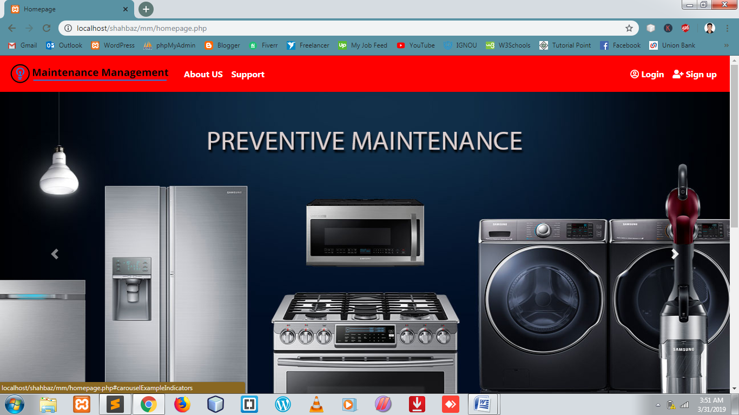

**Homepage Slider**

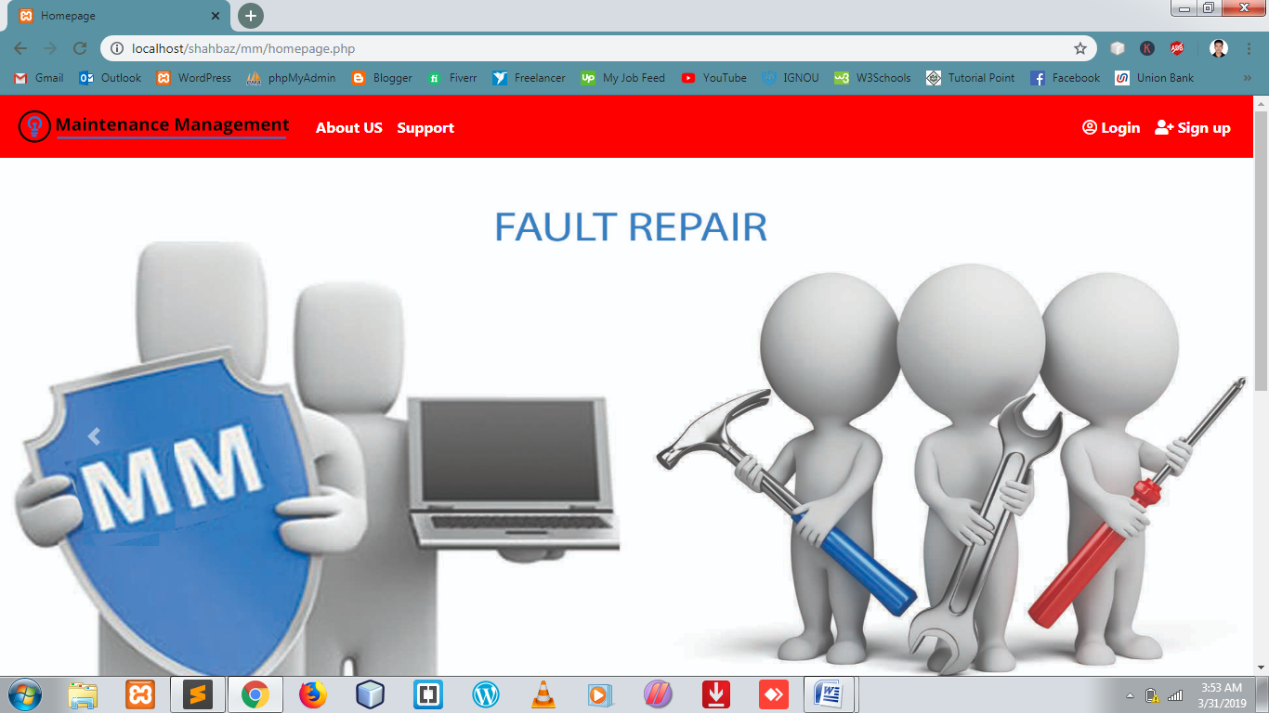

**Homepage after scroll down**

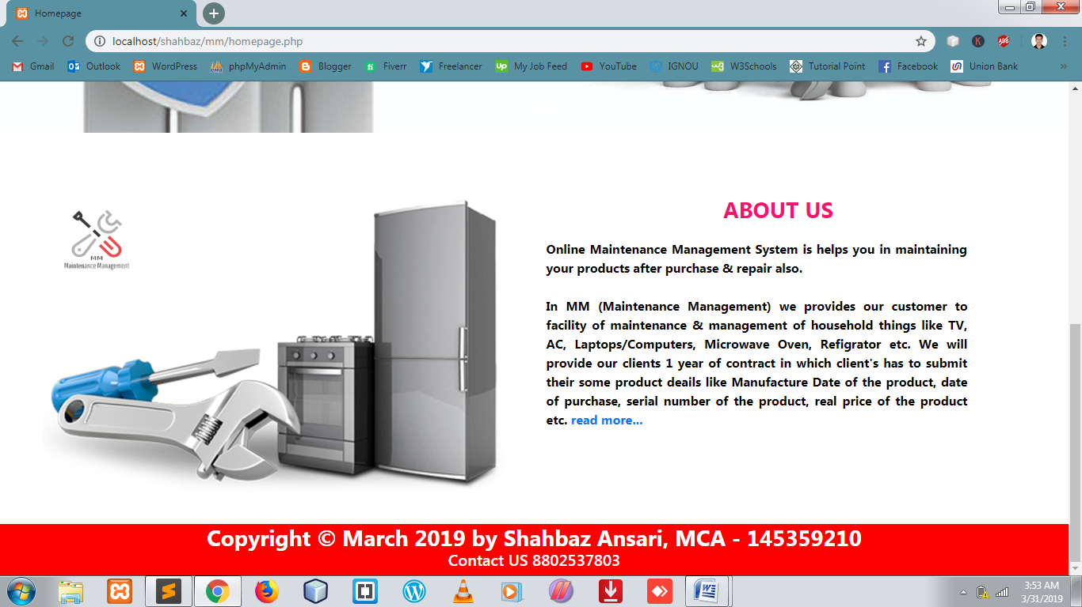

**Full About us**

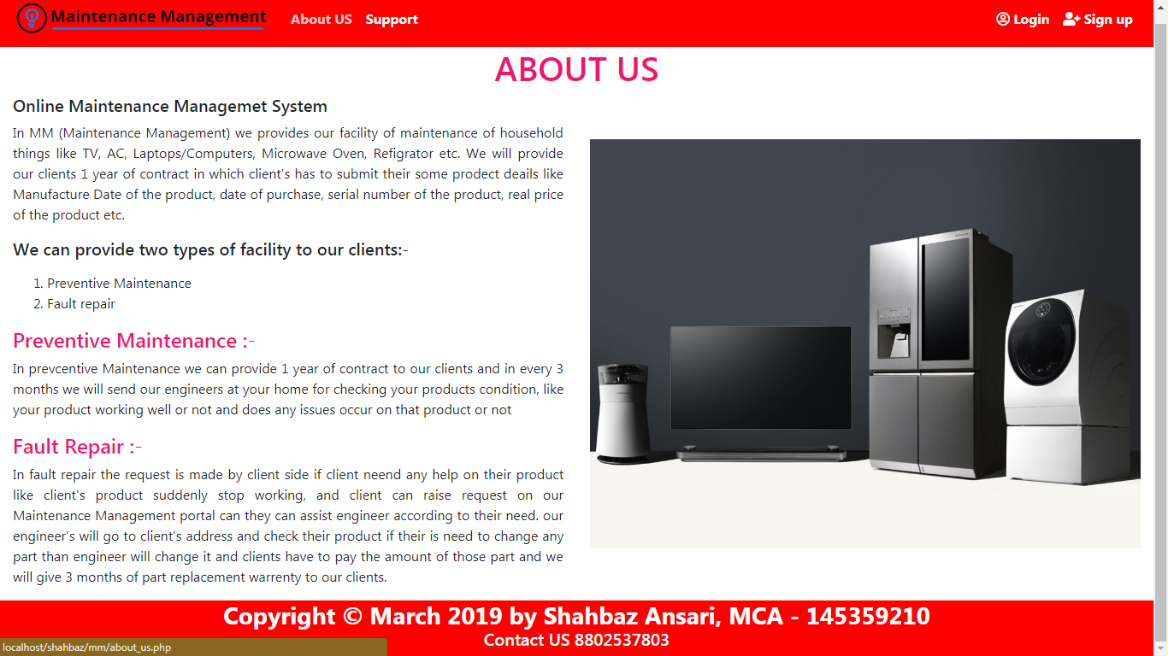

**Details About Preventive Maintenance**

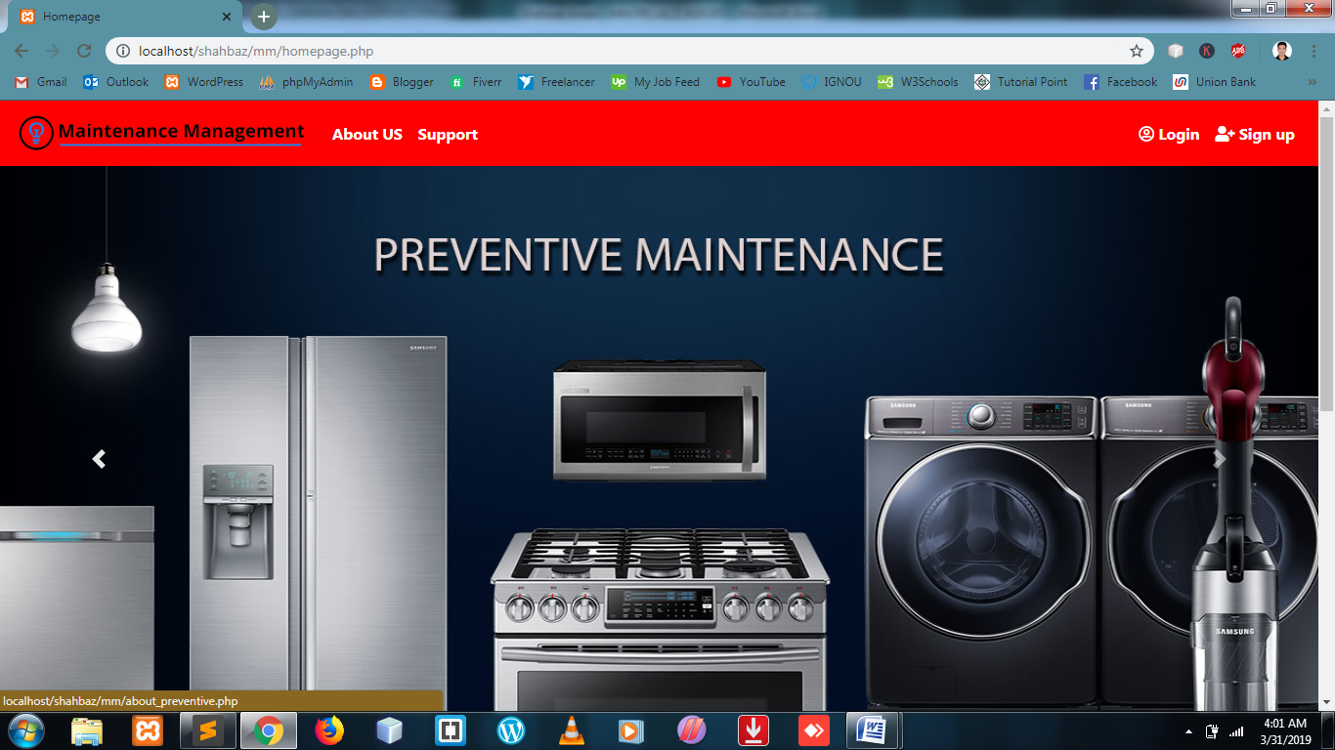

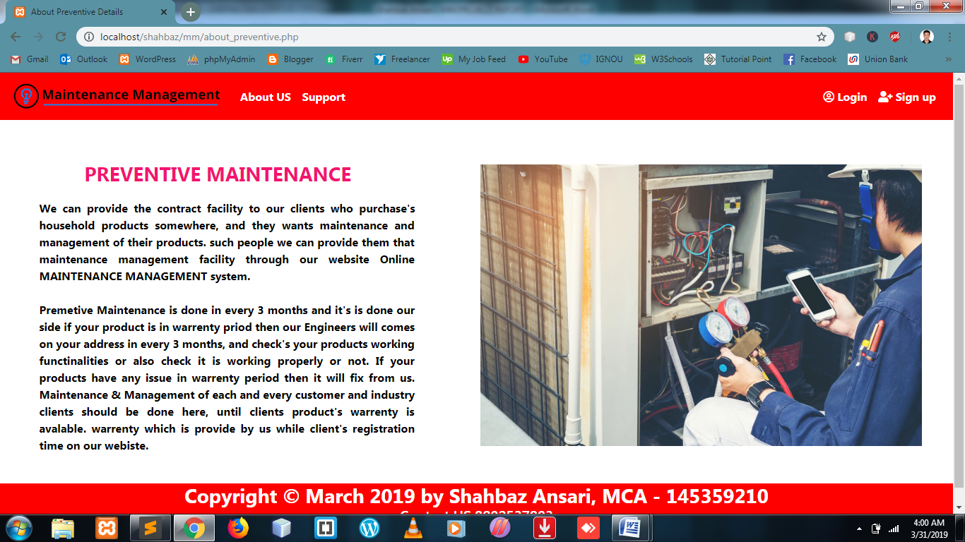

**Details about Fault Repair**

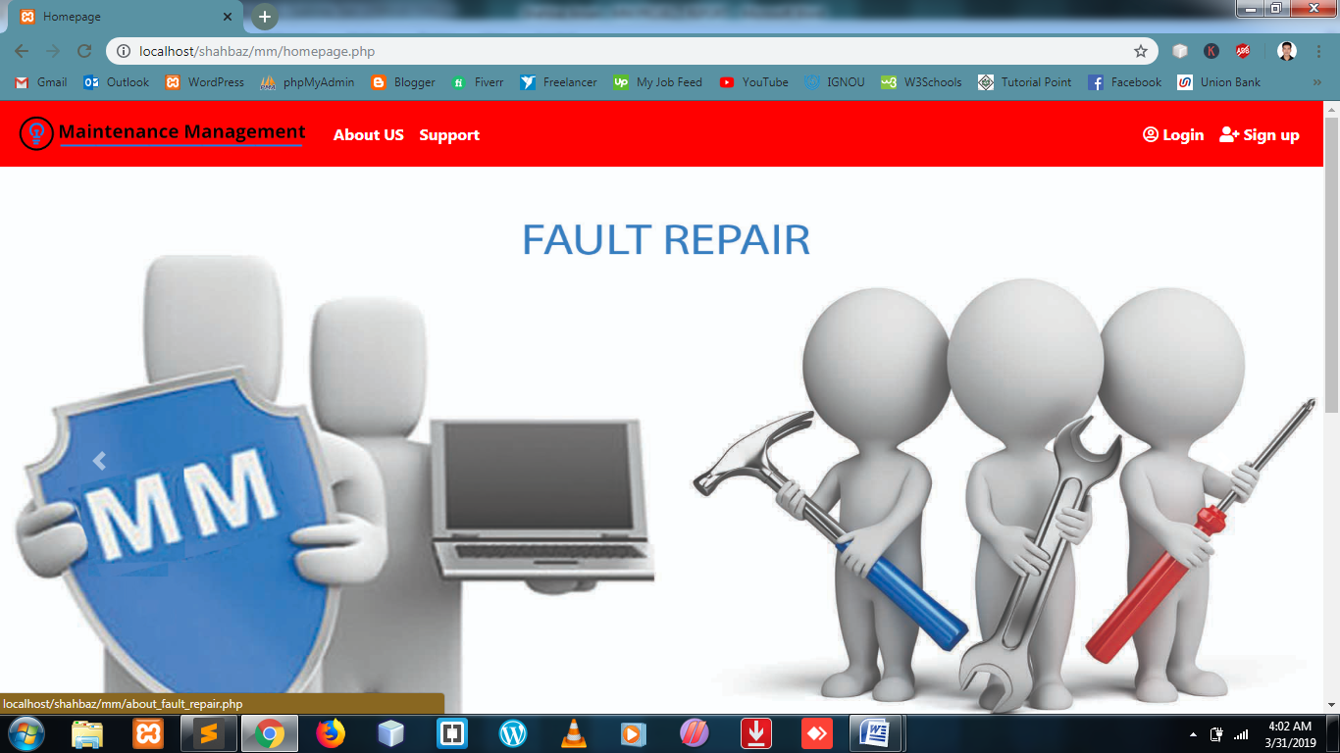

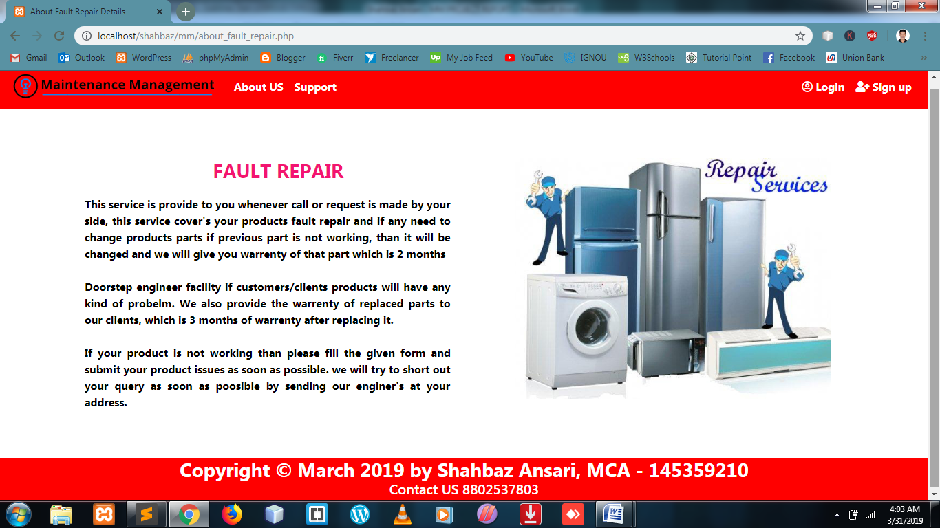

**User Registration Validation**

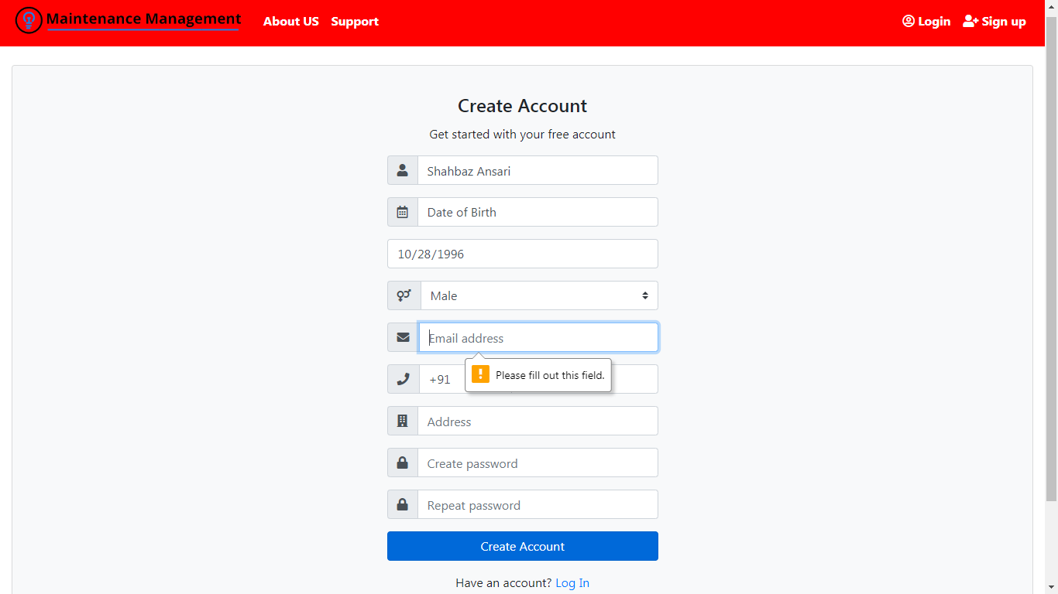

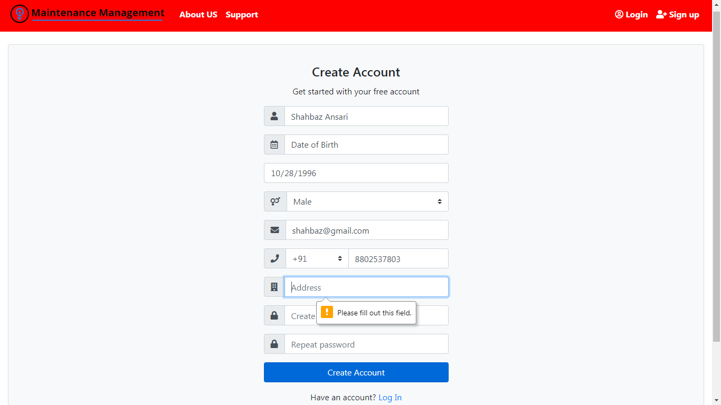

**User Registration Completed**

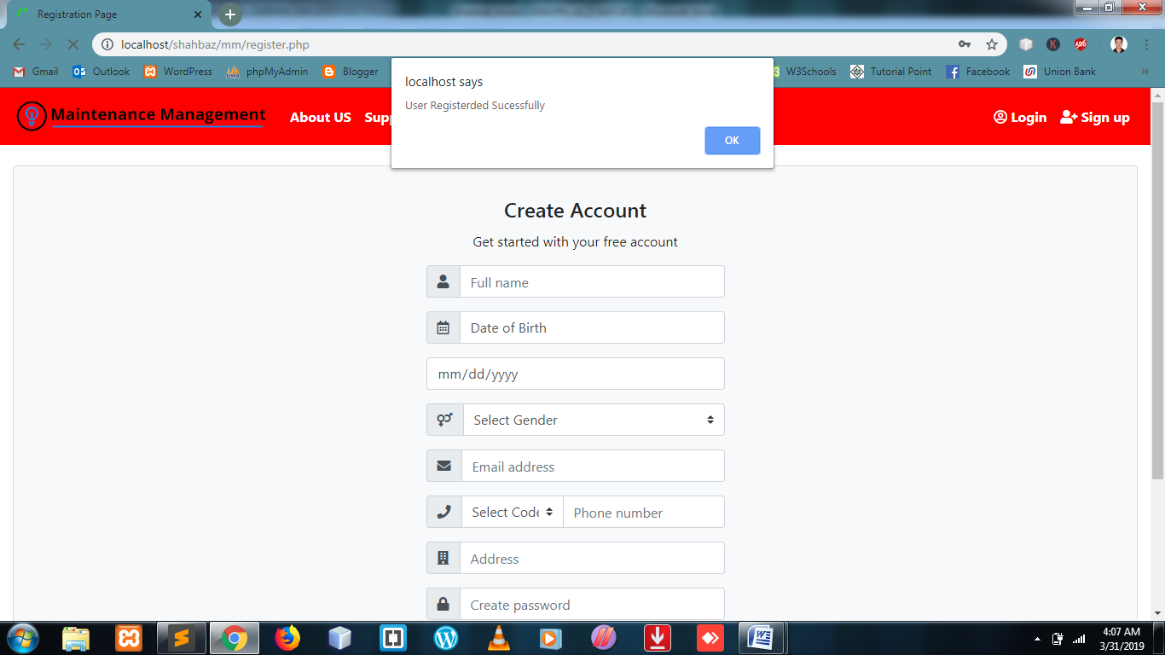

**Redirect to Login Page**

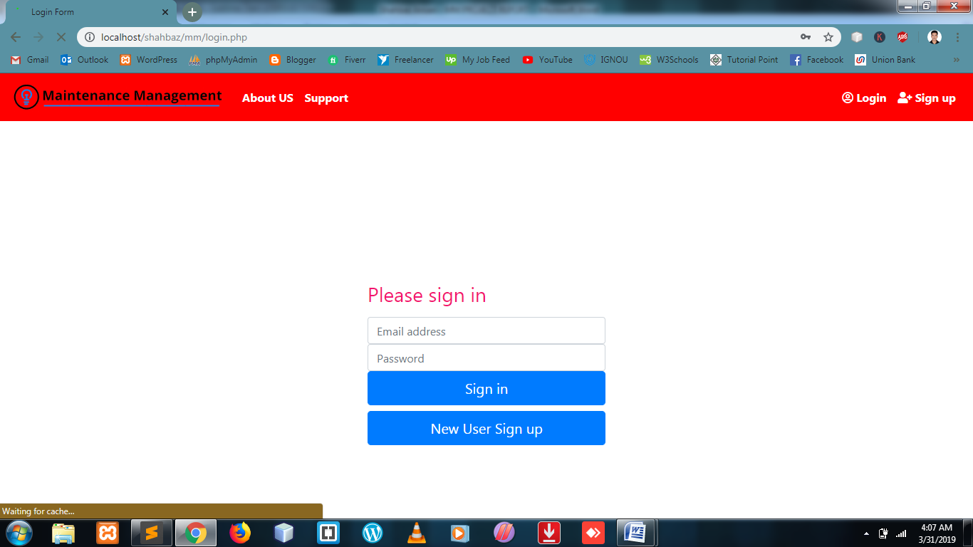

**Login form fill up**

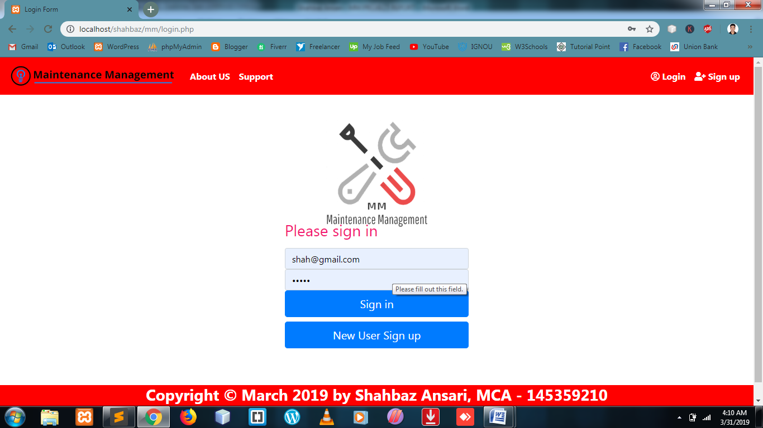

**User Dashboard after Login**

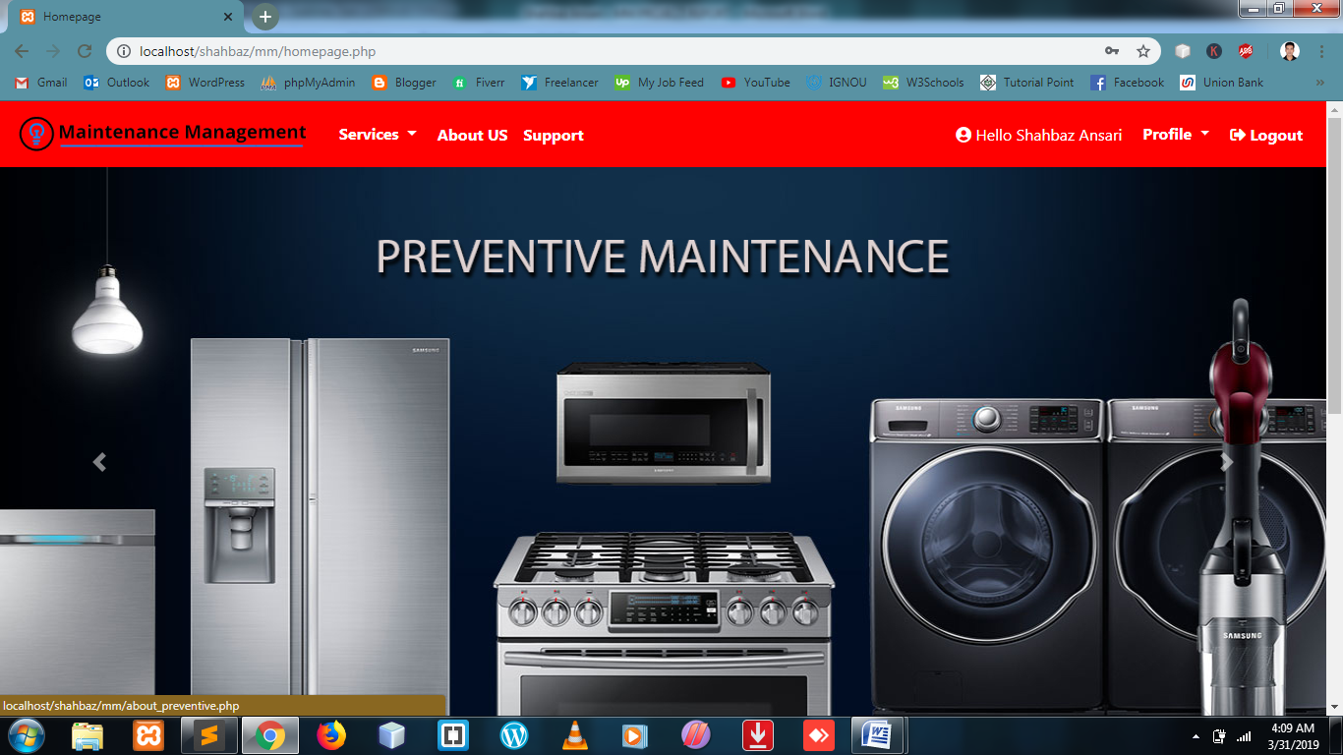

**Our Services**

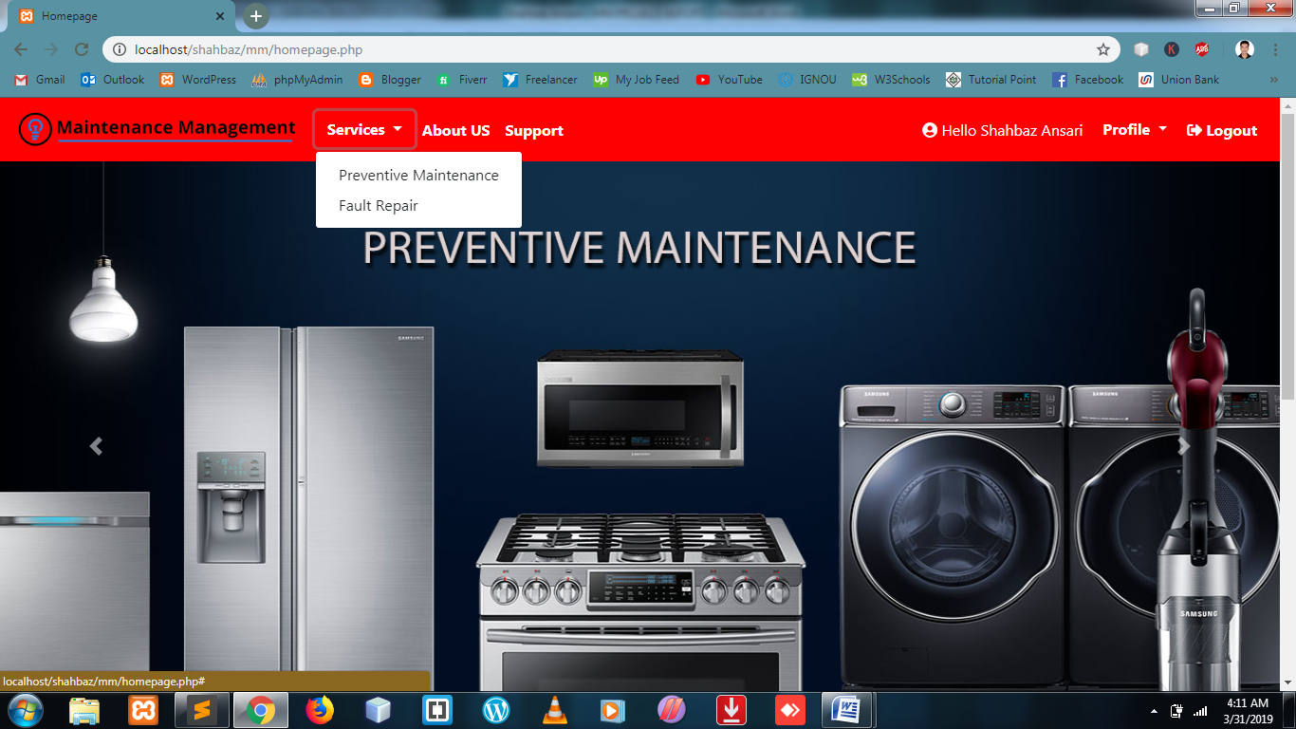

**Preventive Service**

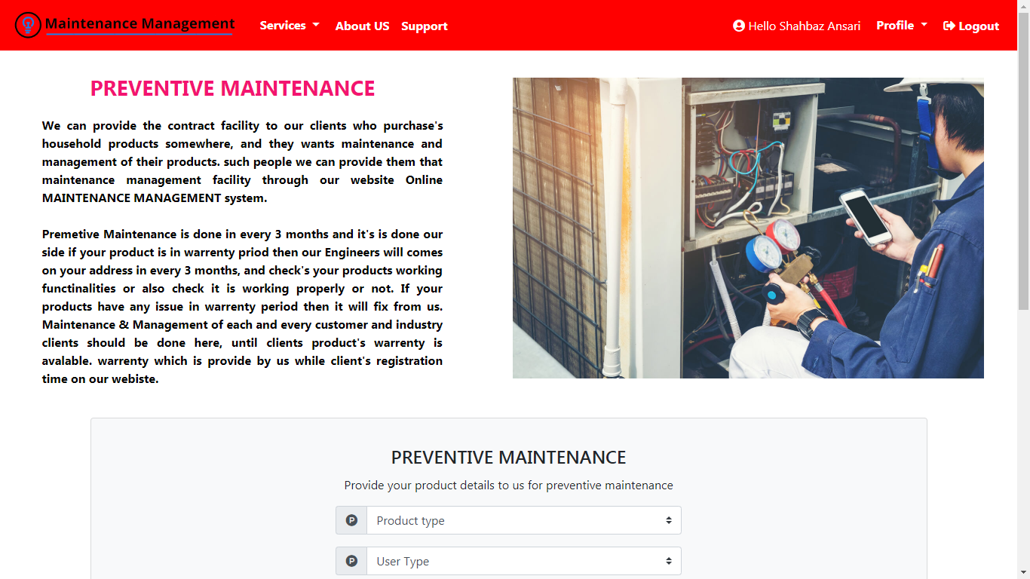

**Preventive Service**

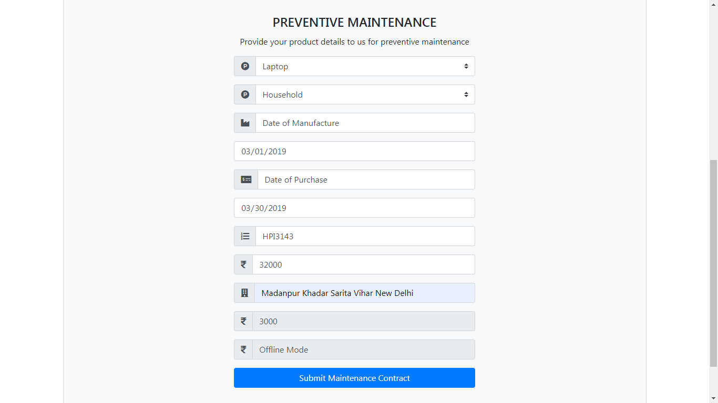

**Preventive Service**

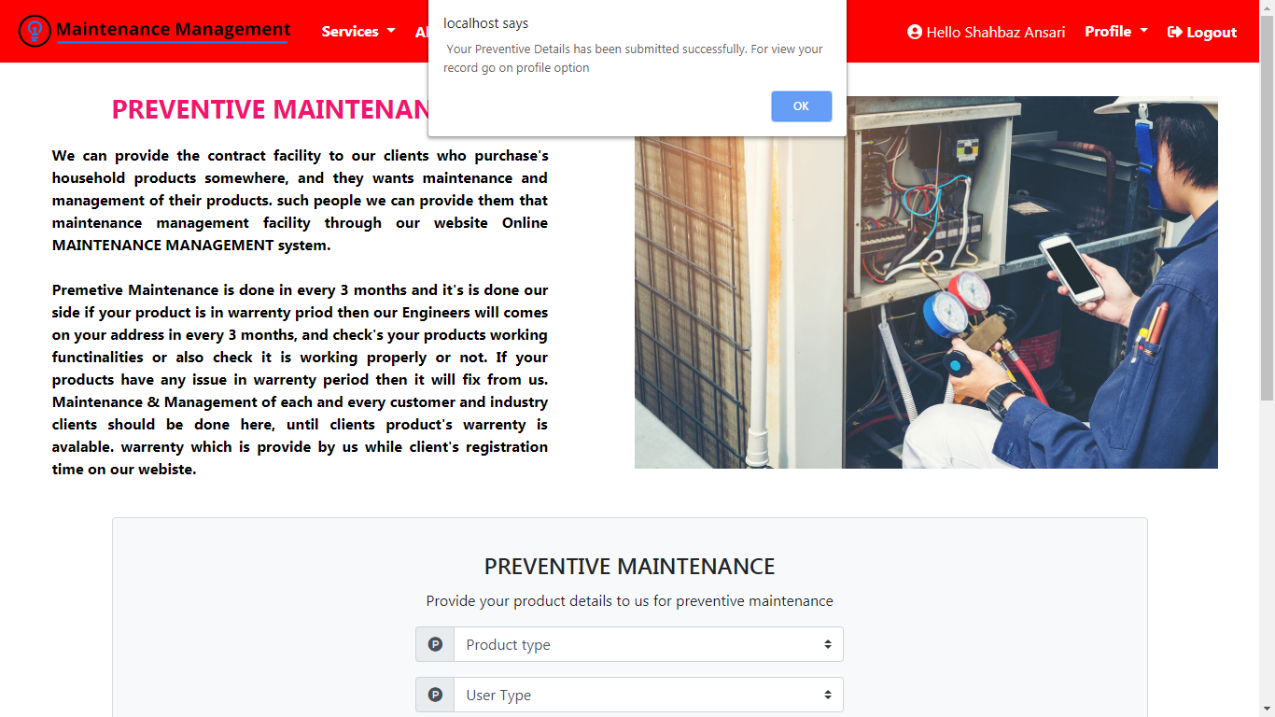

**Fault Repair**

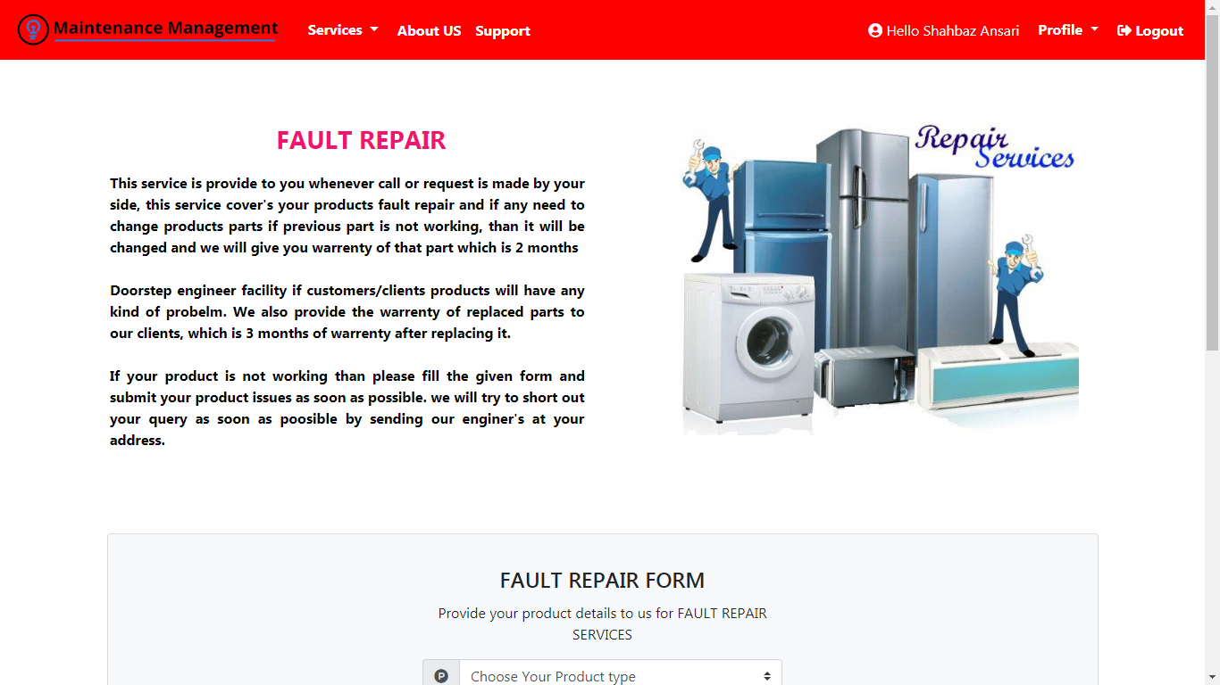

**Fault Repair**

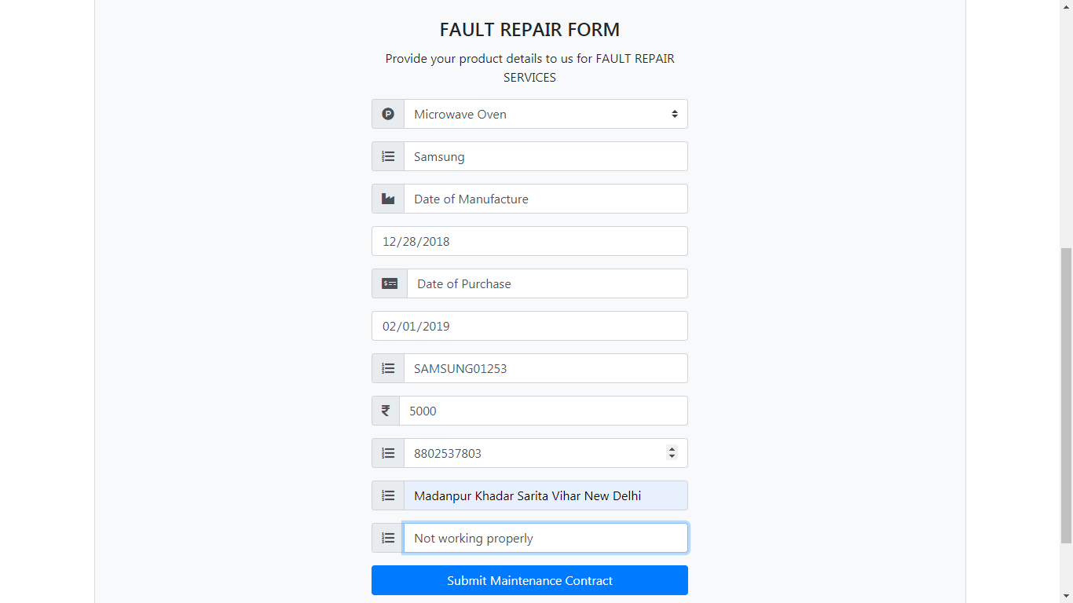

**Fault Repair**

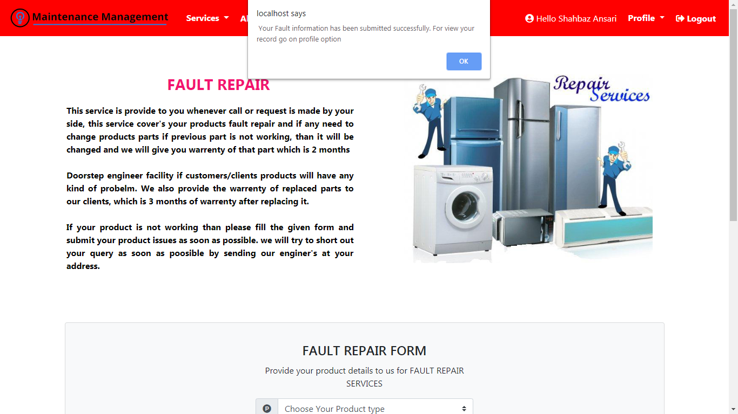

**Support**

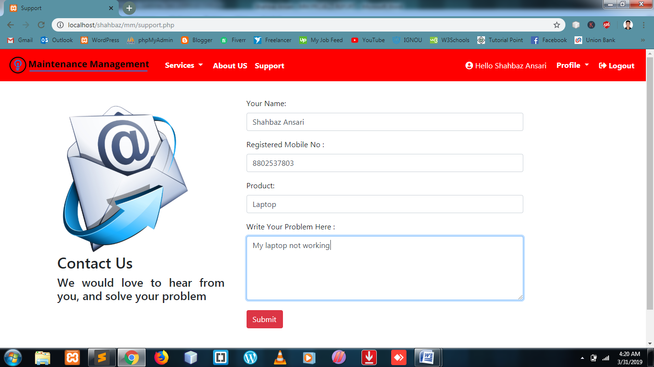

**Support**

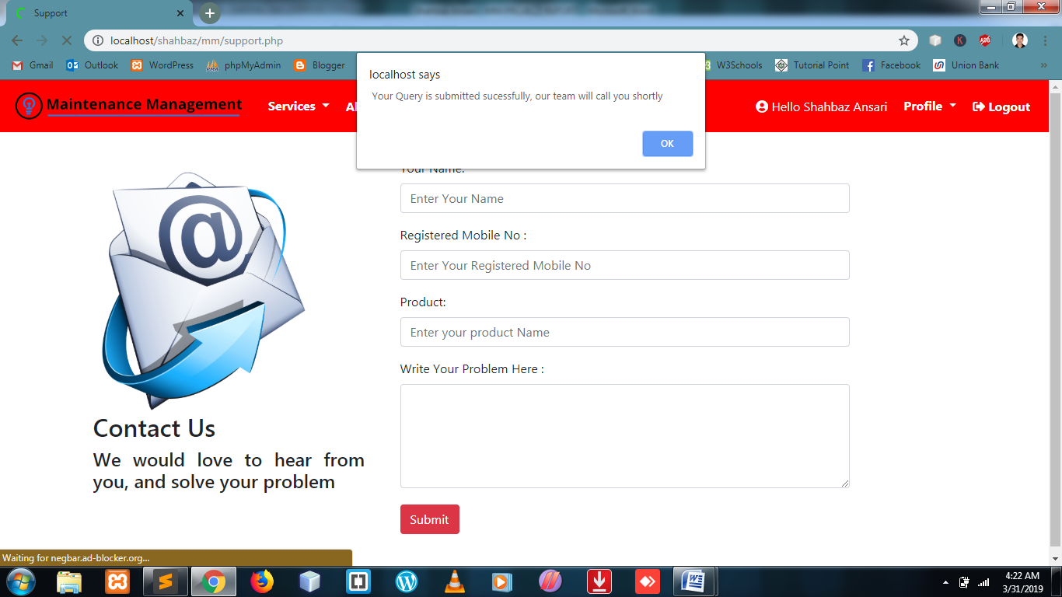

**User Profile Option**

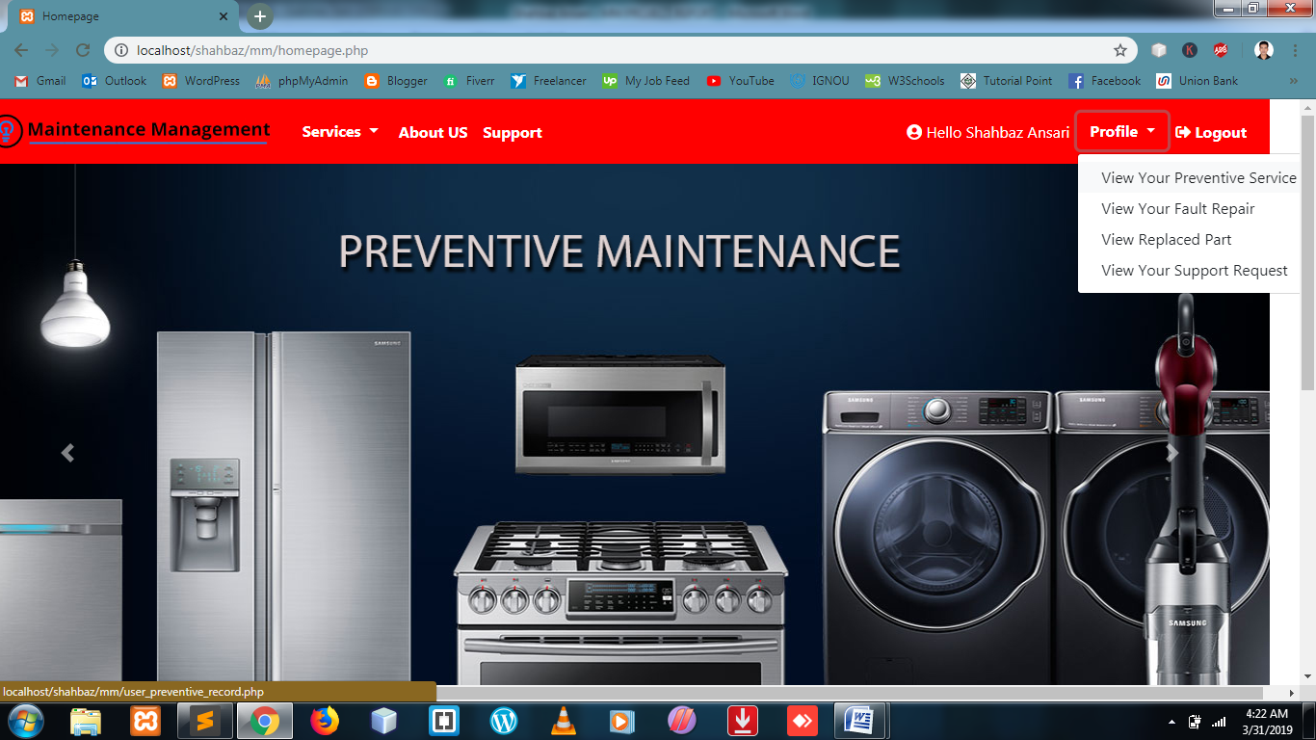

**User’s Preventive Record**

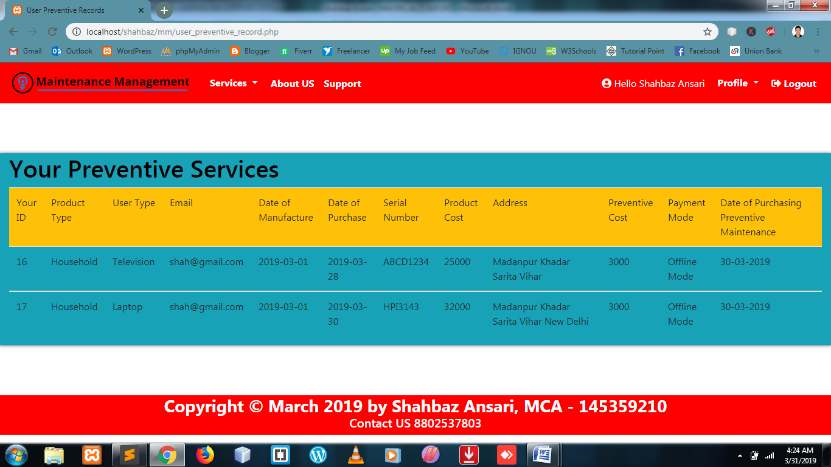

**User’s Fault Record Submited by User**

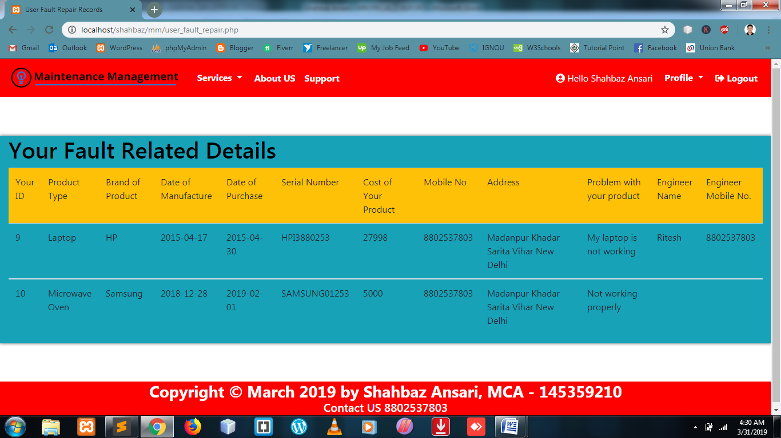

**Part replaced after visiting engineer details**

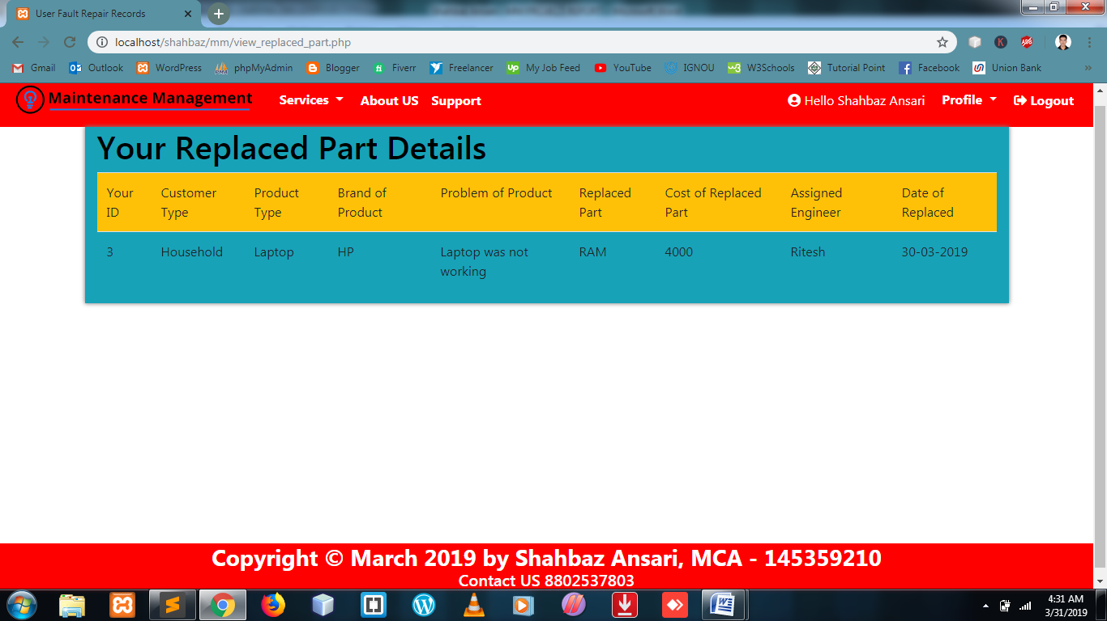

**User’s Support Request Page**

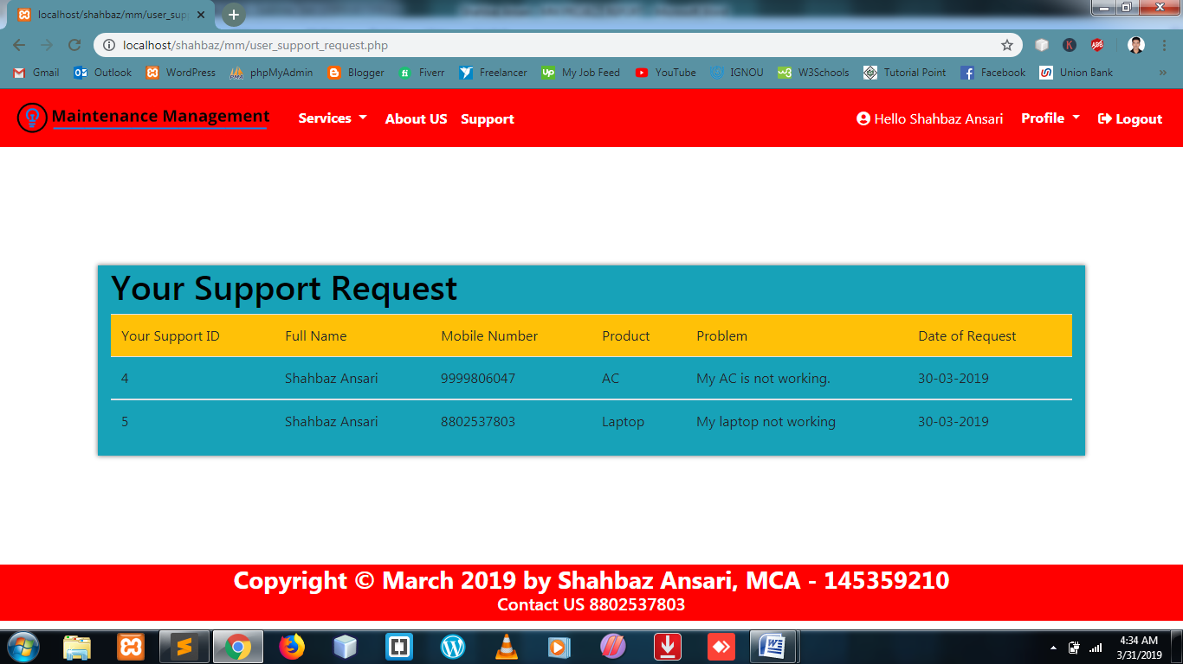

**Admin Area (login)**

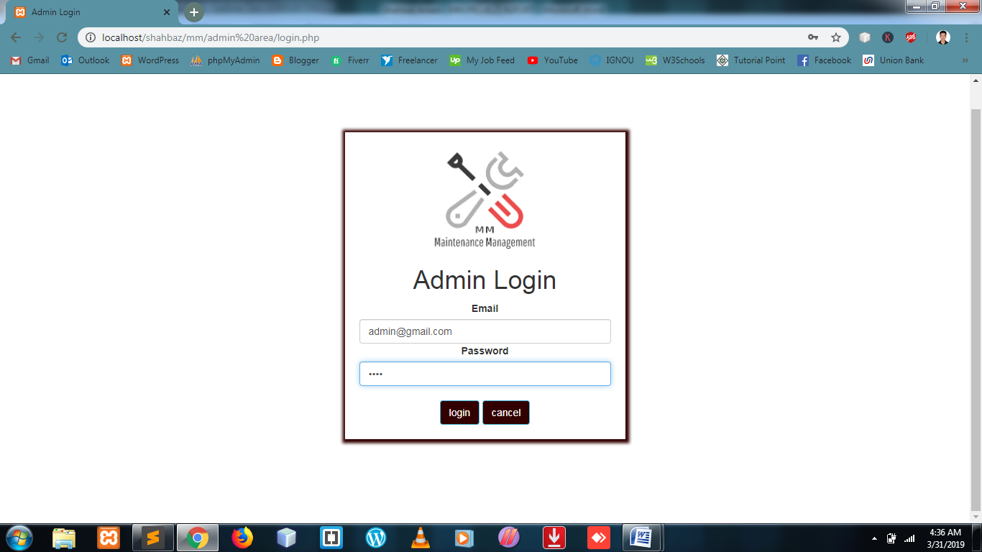

**Admin Homepage**

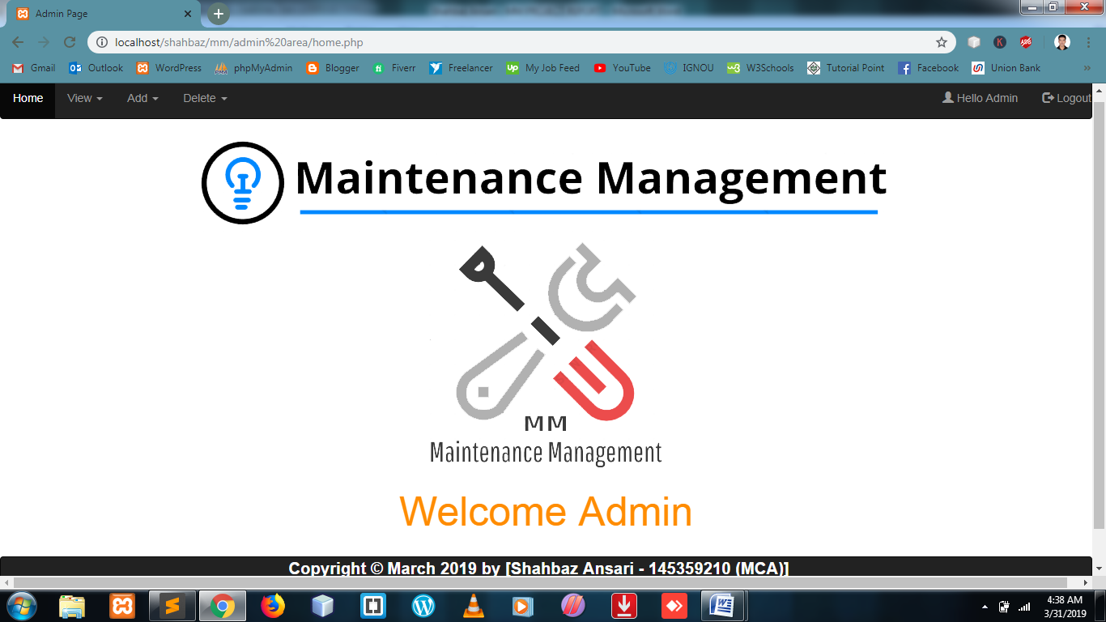

**Admin View Details**

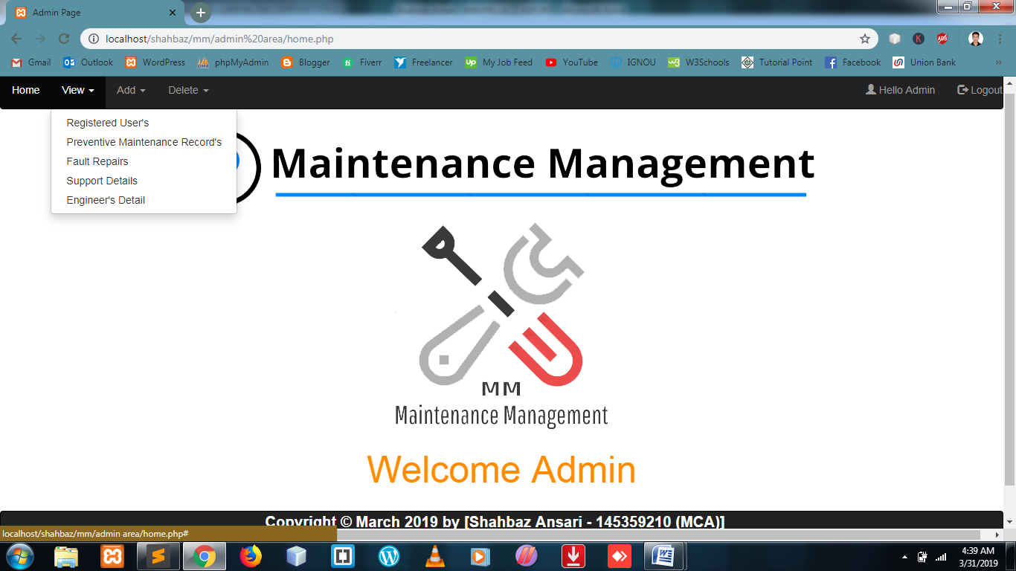

**View Registered User Details**

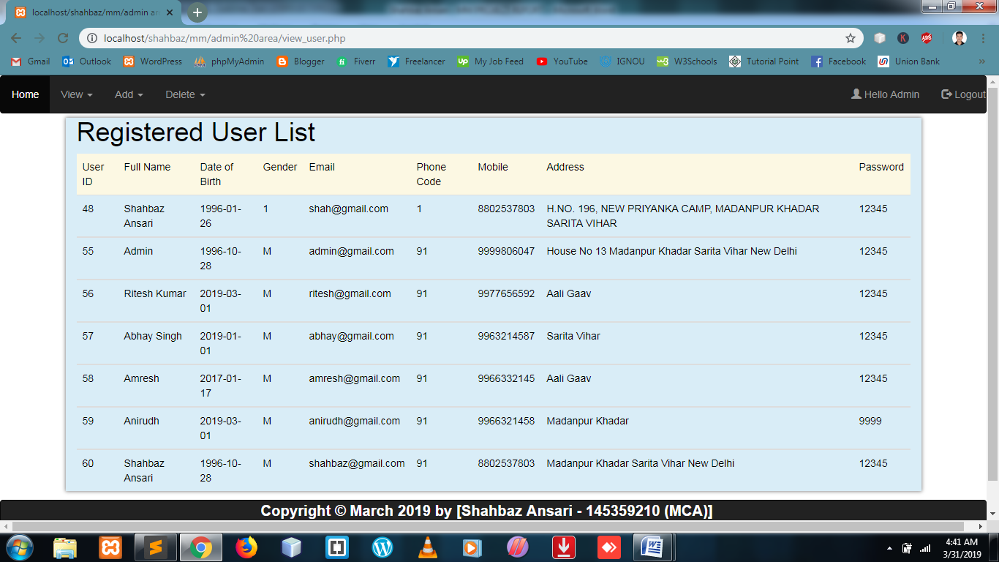

**View Preventive Maintenance Record**

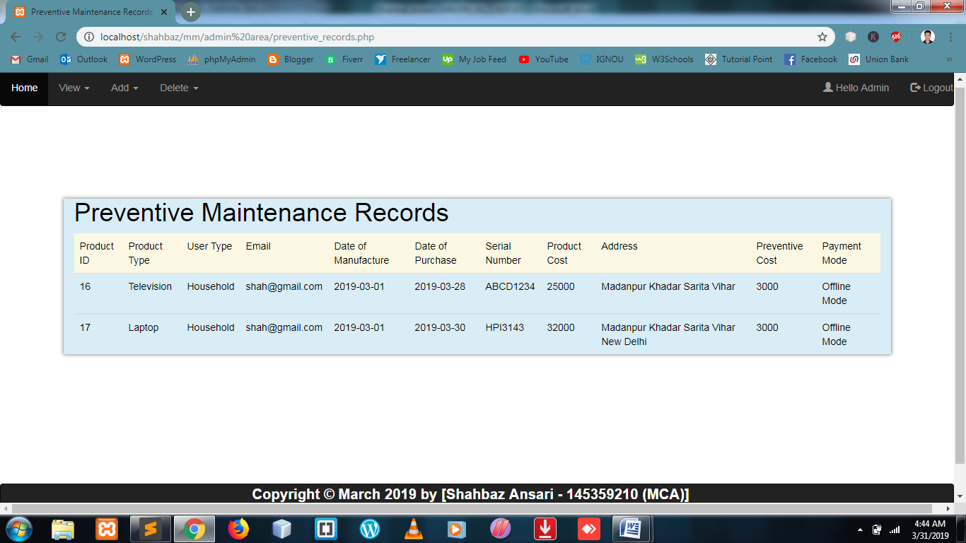

**View Fault Repair Records**

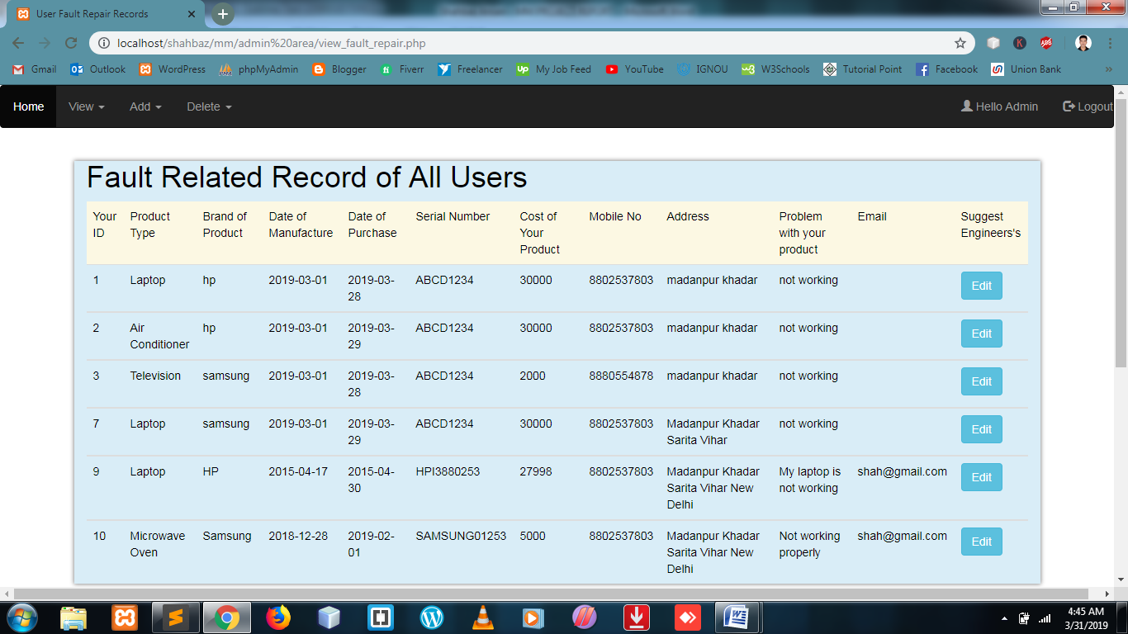

**Assign Engineer to fault repair service**

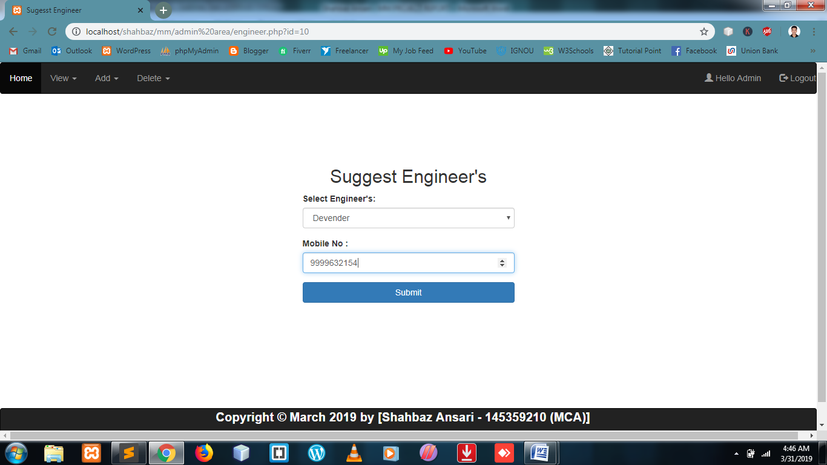

**Engineer Assign Sucessfully on User Page**

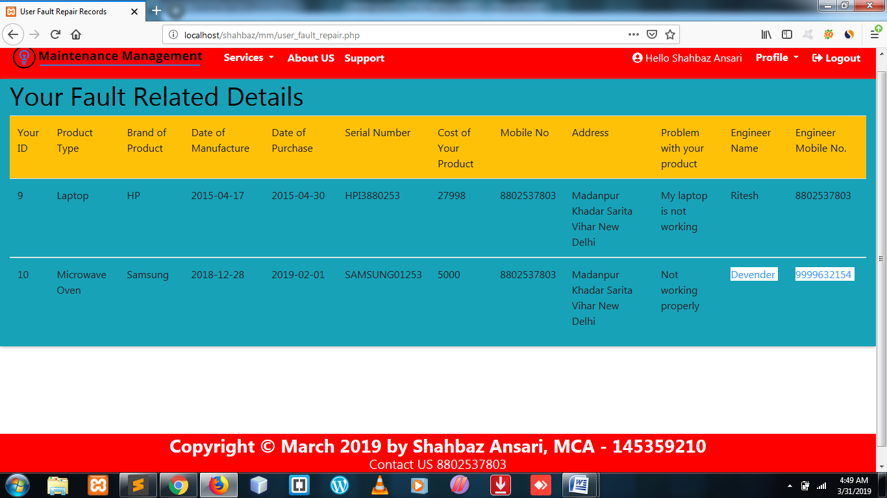

**Support Records of User in Admin Dashbord**

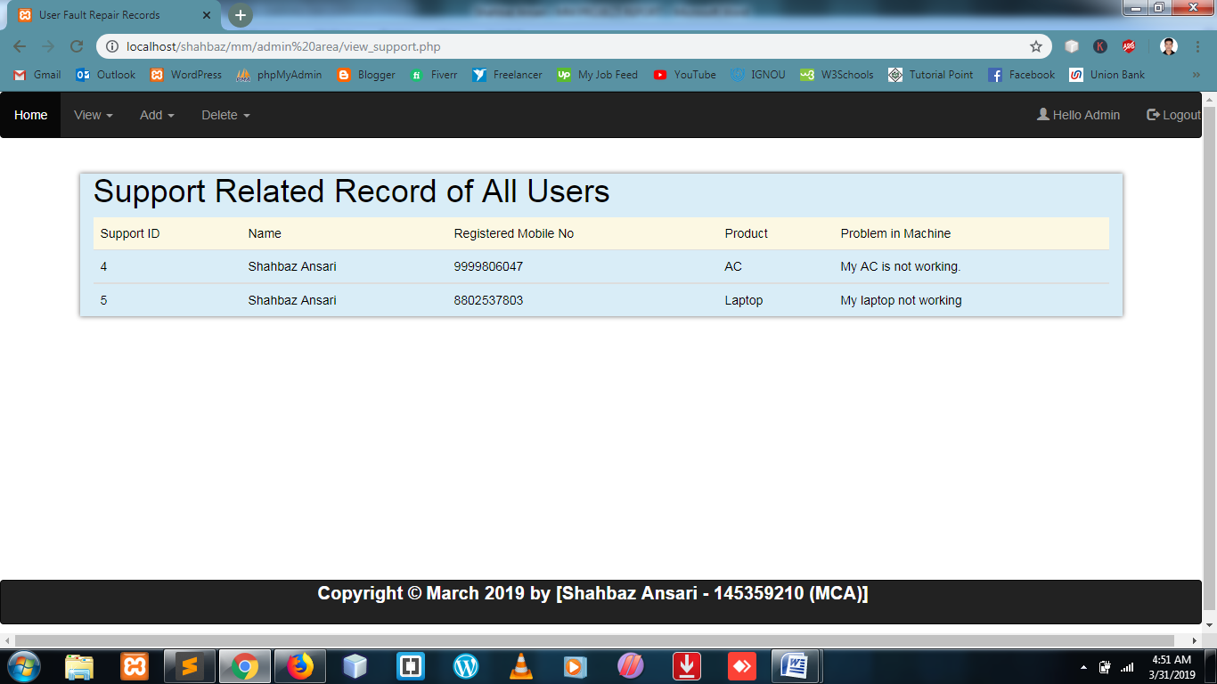

**Engineer Details**

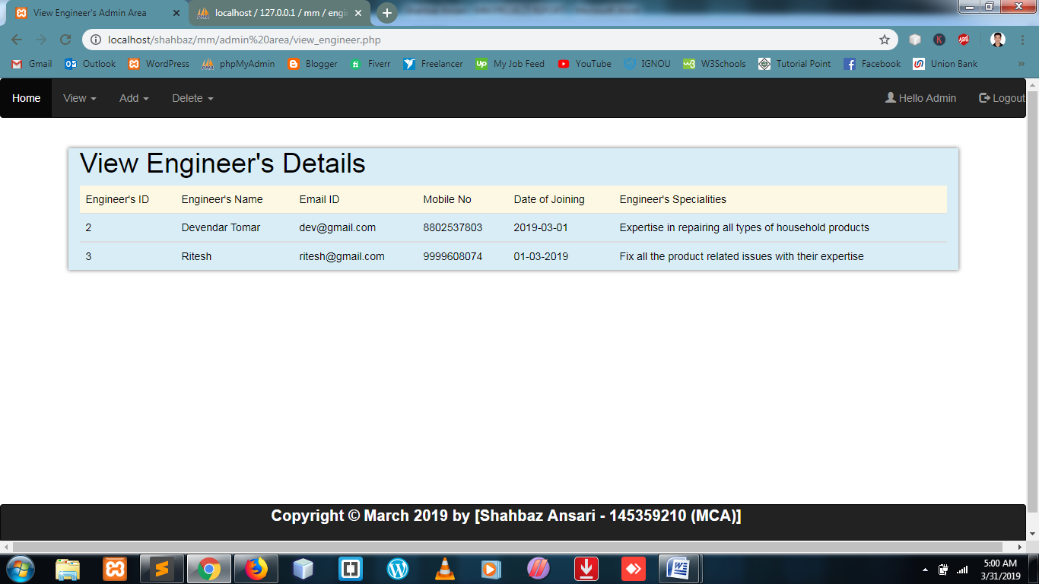

**Admin Add Section**

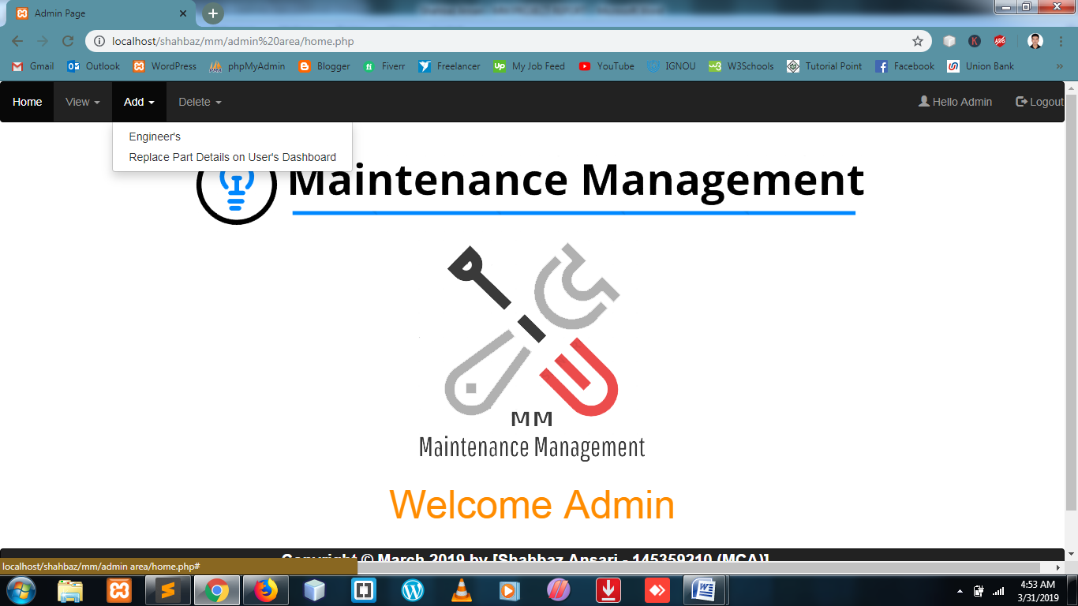

**Admin Add Engineer**

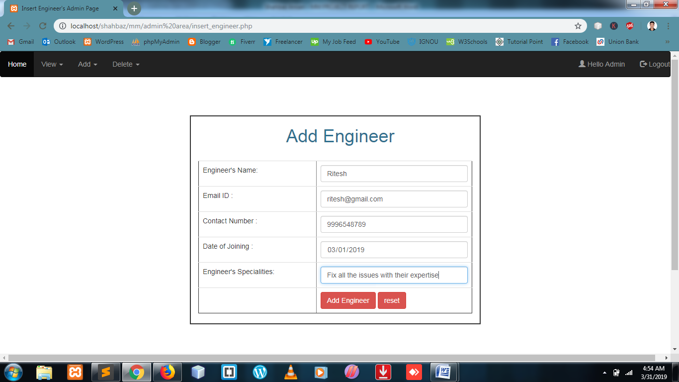

**Admin Add Details of Part Replaced on User Account**

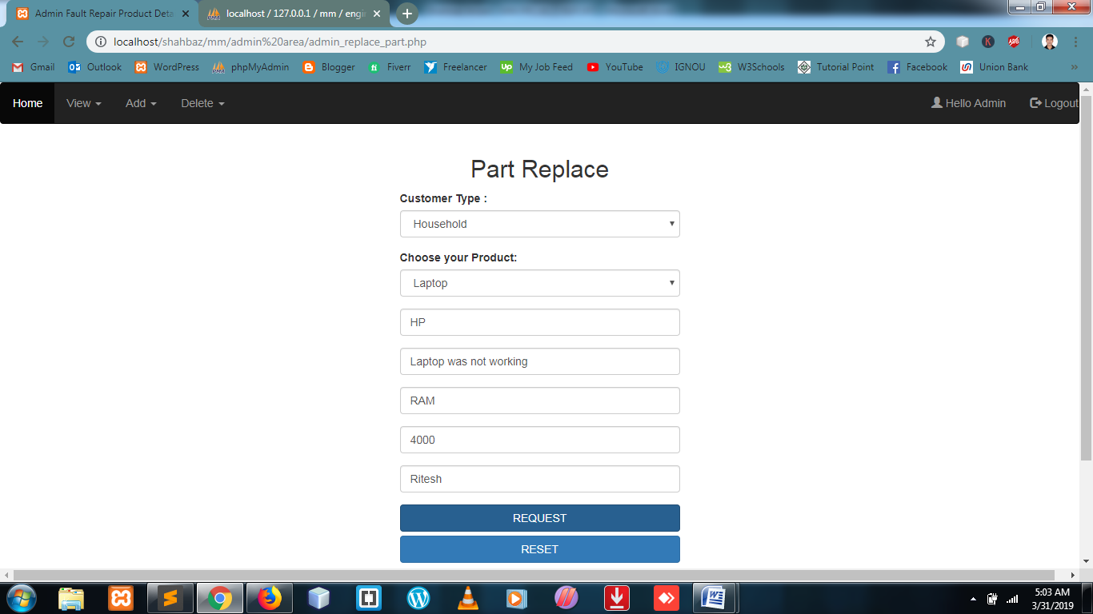

**User Dashbord after updating part replaced**

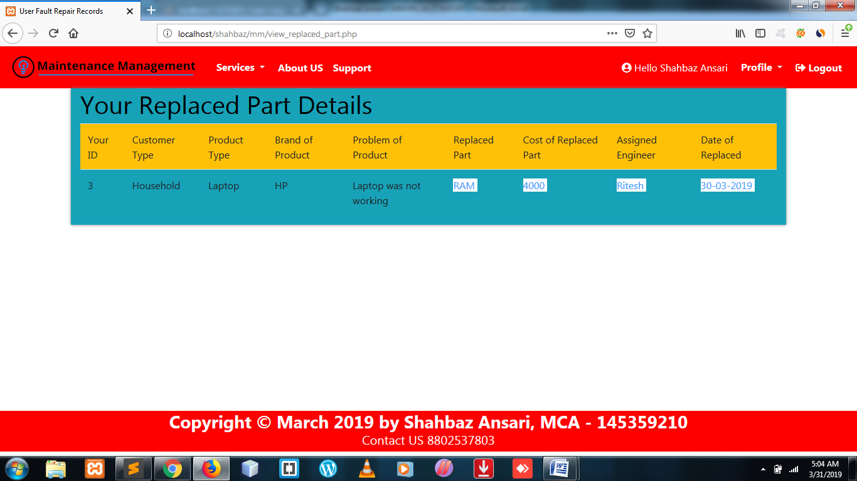

**Admin Delete Section**

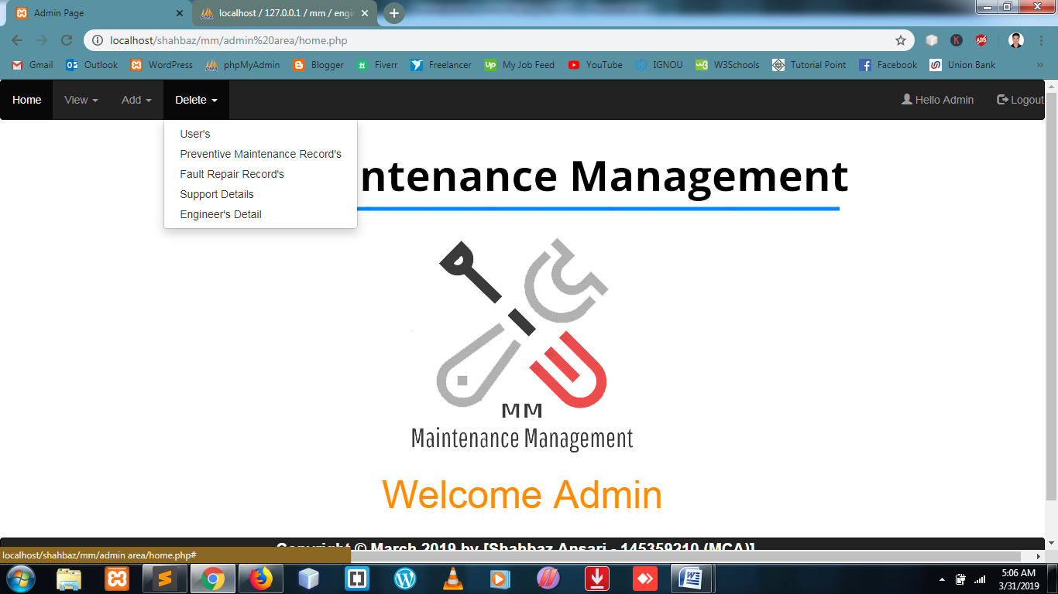

**Slection on that user which I want to delete**

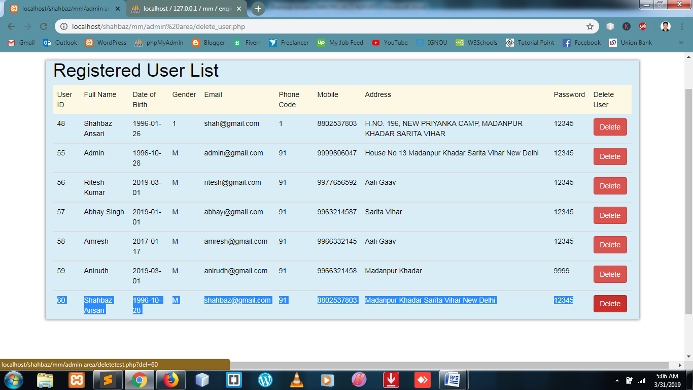

**User delete successfully**

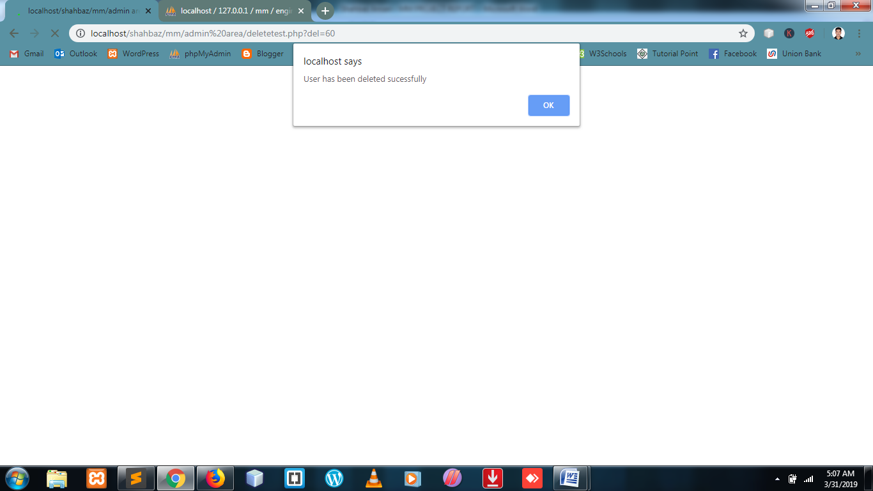

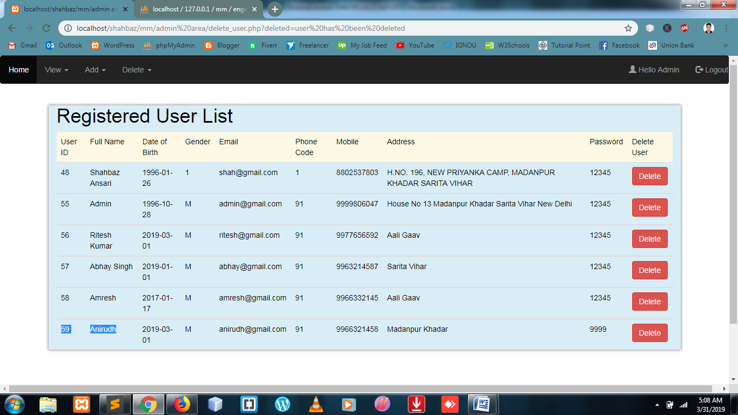

**Delete Page of Preventive Service Record**

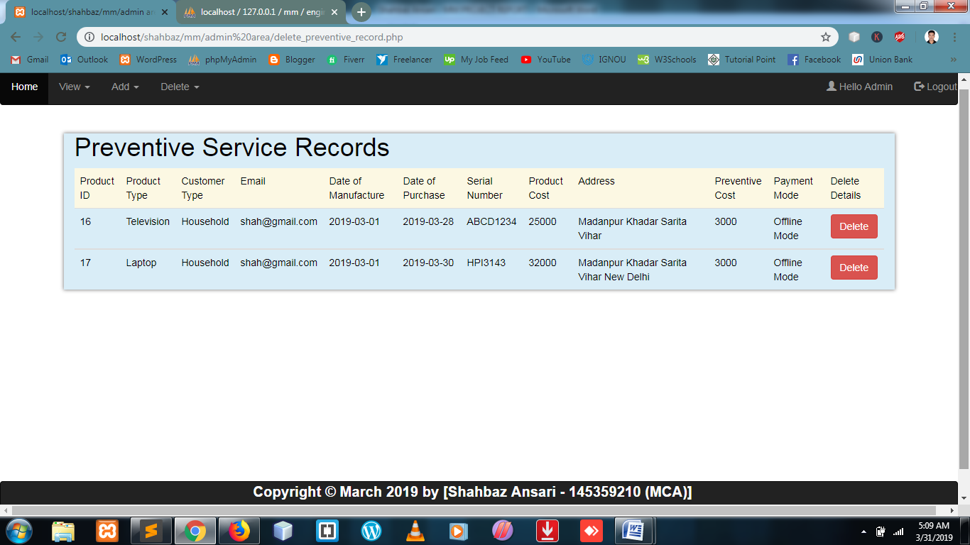

**Delete Fault Repair Service Record Page**

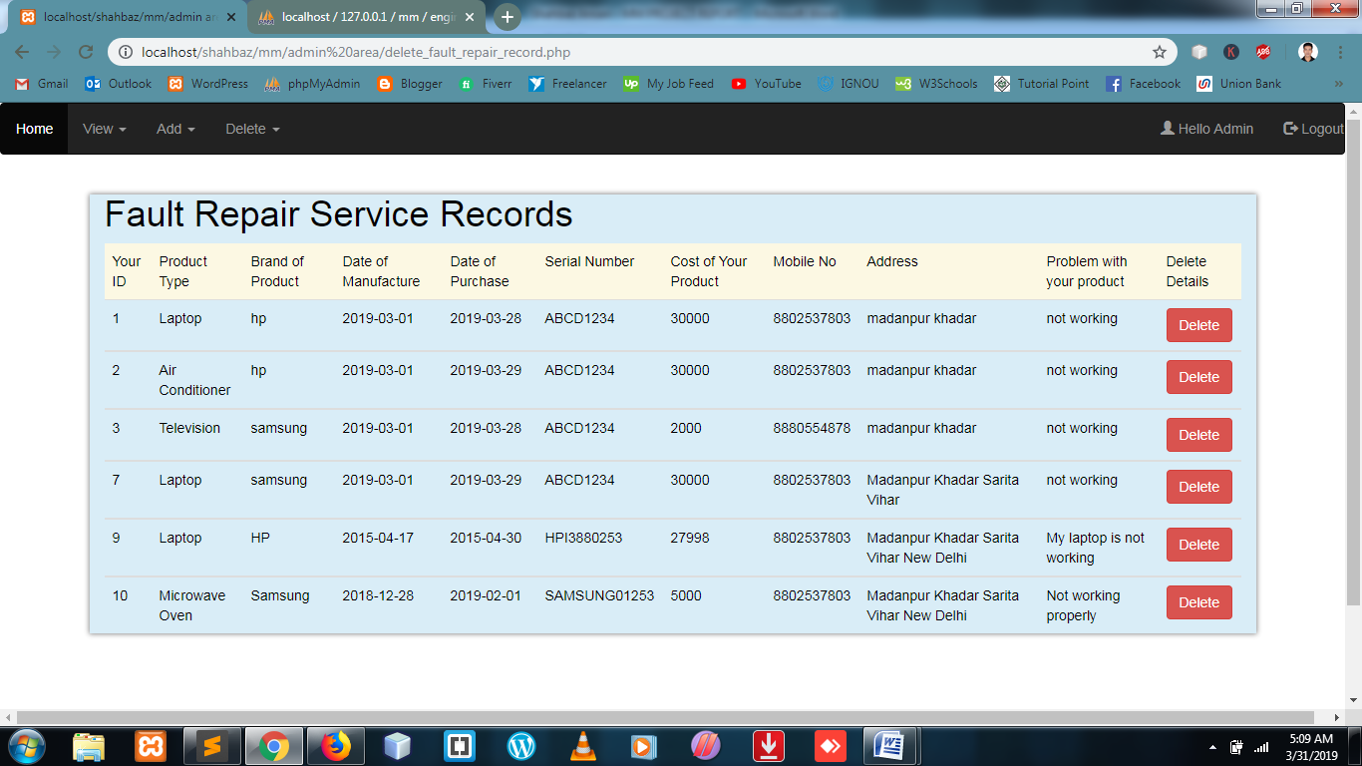

**Delete Support Record Page**

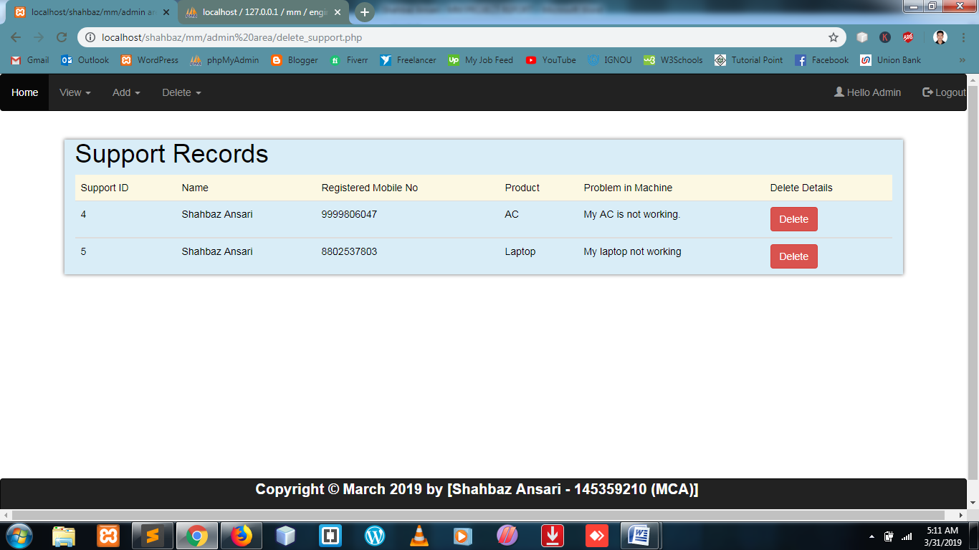

**Delete Engineer’s Record Page**

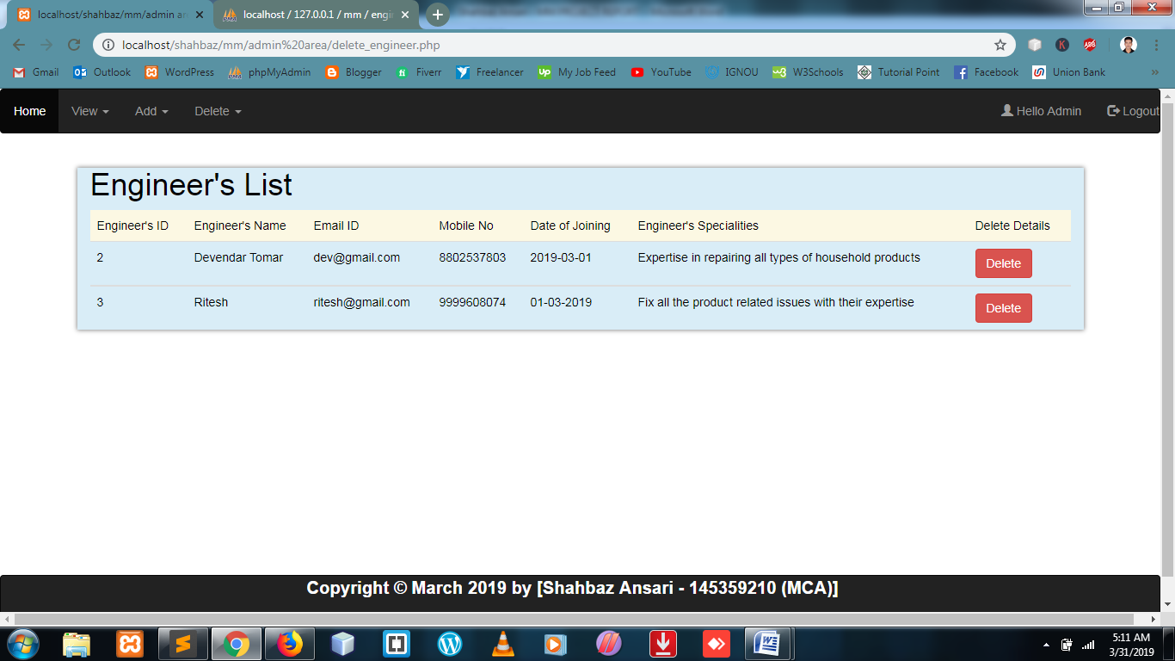

In the software security there are two levels of security. The 1st level of security, which is provided by the FRONT END and 2nd level of security provided by the database which is being used.

**- FRONT END**

We have implemented **PHP and HTML 5, CSS3, Bootstrap 4.0**  for all the Client side validations. Client side JavaScript is designed to reside inside HTML document & ensure they run properly. It is object based, event driven, platform independent. These are important parts of any Web application to implement Client side Validations and the invalid data is not submitted. The form is not submitted until user fills in correct data. It is extremely useful to restrict mistakes by user.

We have implemented **PHP** in between which is fetching the data values given by the user and storing the input into database (into appropriate tables).PHP use to make connection with database and store data. PHP provides support to execute queries via creating objects of Statement and Connection Interfaces. PHP are object byte codes that can be dynamically loaded off the Internet. PHP are platform independent, dynamically loadable.

**-BACK END**

The PHP MyAdmin database has become the world’s mots popular open source database because of its consistent level of fast performance, high reliability and ease of use. It is used everywhere and by everyone.Individuals, web developers, and many of the world’s largest and

Fastest-growing organization.Usually, security is not amajor consideration when installing

Mysql, if it ask for password and user name is by default is “**root**” when we create connection in PHP page we use Driver for connection established with “**localhost:3306”** and We need to write **username** and **password** when we wants to create connection if we cant use username or password then we cant established connection with mysql.

There are some limitations for the current system to which solutions can be provided as a future development:

* Offline Mode is the only Payment mode available.
* User interface is only in English i.e. no other language option is available.
* User can login only with his assigned username and passwords i.e. no guest facility is available.

The proposed of making the system of Online Maintenance Management System will provide good way Maintenance Service to everyone of their products. But like other software it also needs constant improvement based on marketing demands. Thus, this application fits into the current scenario, which is the information age. The current Process we will provide only one product at time , but In future we will provide more improvement on the website, and “add to cart” products.

**Future scope of the project:**

Today, the market place is flooded with several maintenance appointments options for users to choose from. A variety of innovative products and services are being offered spoiling customers for choice. Online maintenance management system (MM) system is no more a privilage enjoyed by your friends and family today it is a reality in india. In the last couple of years, the growth of online maintenance management syste industry in india has been phenomenal as more shoppers have started discovering the benefits of using this platform there is enough scope for online businesses in the future if they understand the indian users psyche and benefits to their needs.

* PL/SQL Programming By Ivan Bayross
* HTTTP://WWW.JAVATPOINT /CODE CRUNCH.COM
* HTTP://WWW.W3CSHOOL.com
* PHP and SERVLET [IGNOU BLOCK]
* System Design and Analysis [IGNOU BLOCK]
* Software Engineering [IGNOU BLOCK]
* HTTP://WWW.YOUTUBE.COM